**First install Node JS then install VS Code Setup and Json Server Set UP**

**VS Code Set UP**

Step 1: download VS Code IDE

<https://www.google.com/search?q=download+vs+code+for+windows&rlz=1C1VDKB_enIN1075IN1075&oq=download+vs+c&gs_lcrp=EgZjaHJvbWUqBwgBEAAYgAQyCggAEAAYsQMYgAQyBwgBEAAYgAQyBggCEEUYOTIHCAMQABiABDIHCAQQABiABDIHCAUQABiABDIHCAYQABiABDIHCAcQABiABDIHCAgQABiABDIHCAkQABiABNIBCDM5MTVqMGo3qAIAsAIA&sourceid=chrome&ie=UTF-8>

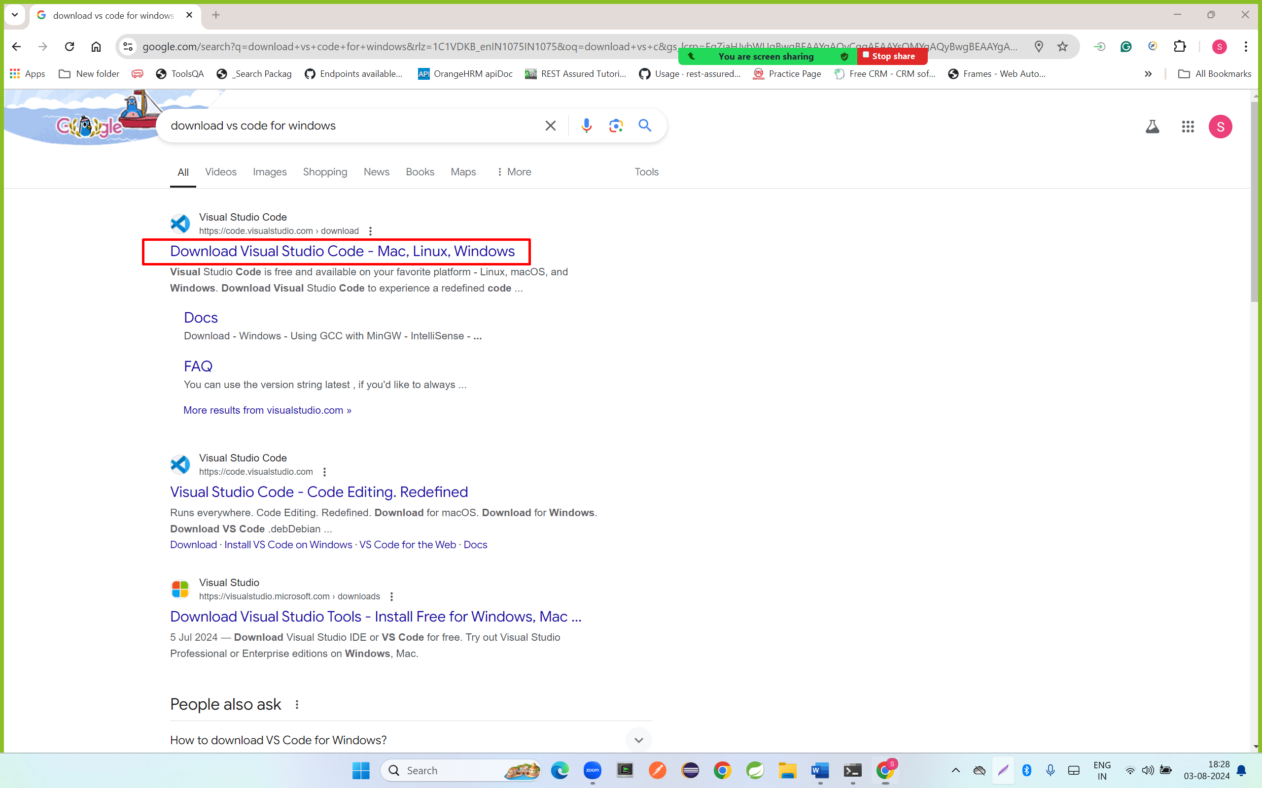

Step 2: click on window 10 or 11

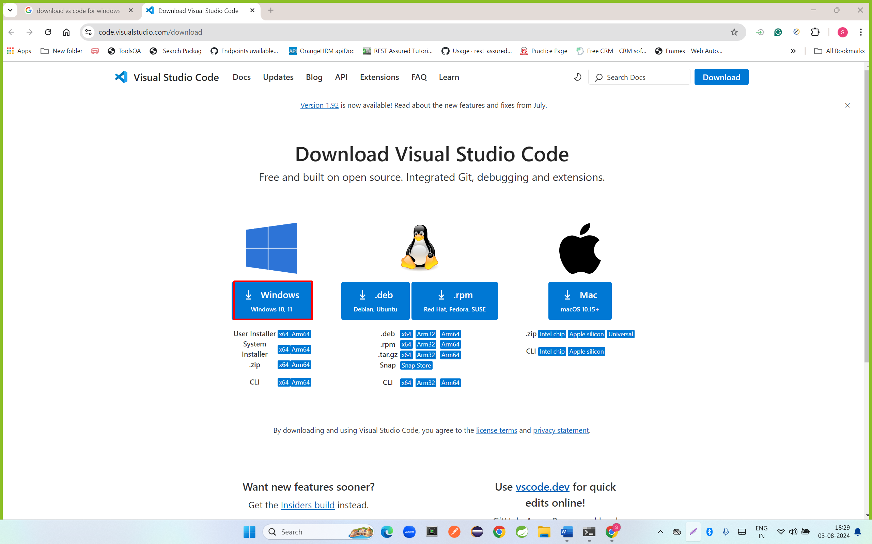

Step 3: double click on vs code file

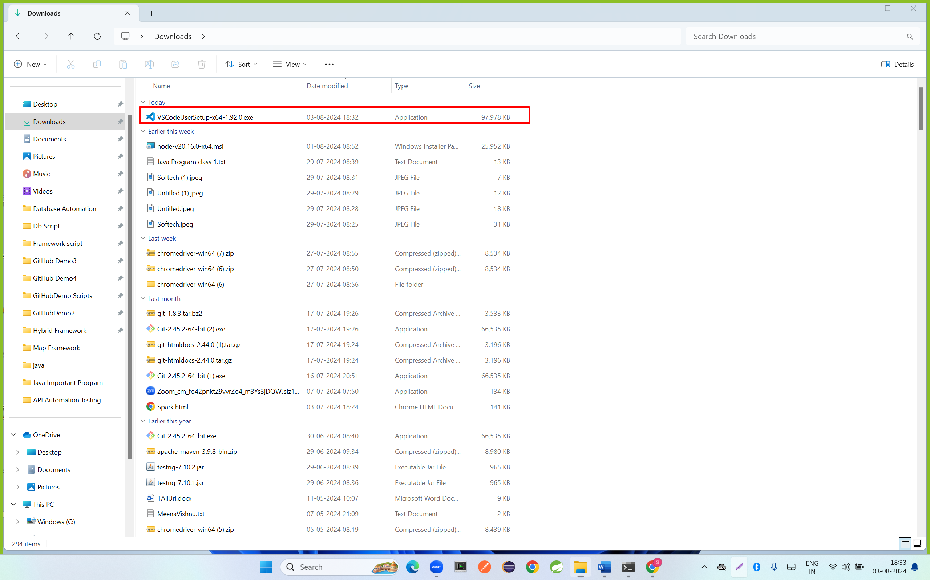

Step 4: click on next button

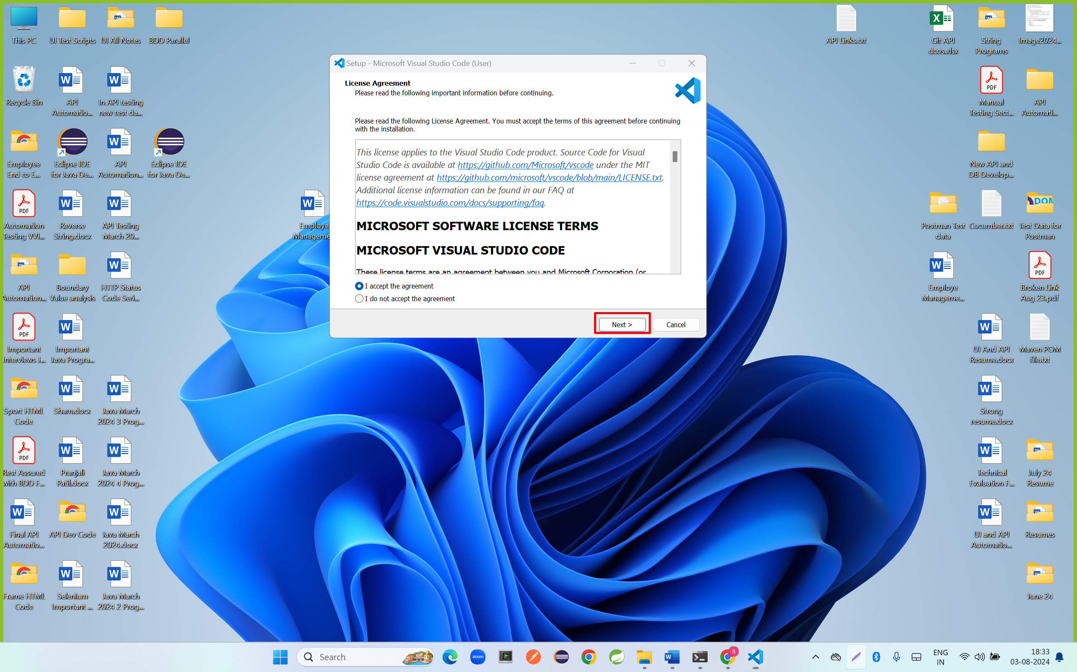

Step 5: select all checkbox and click on next button

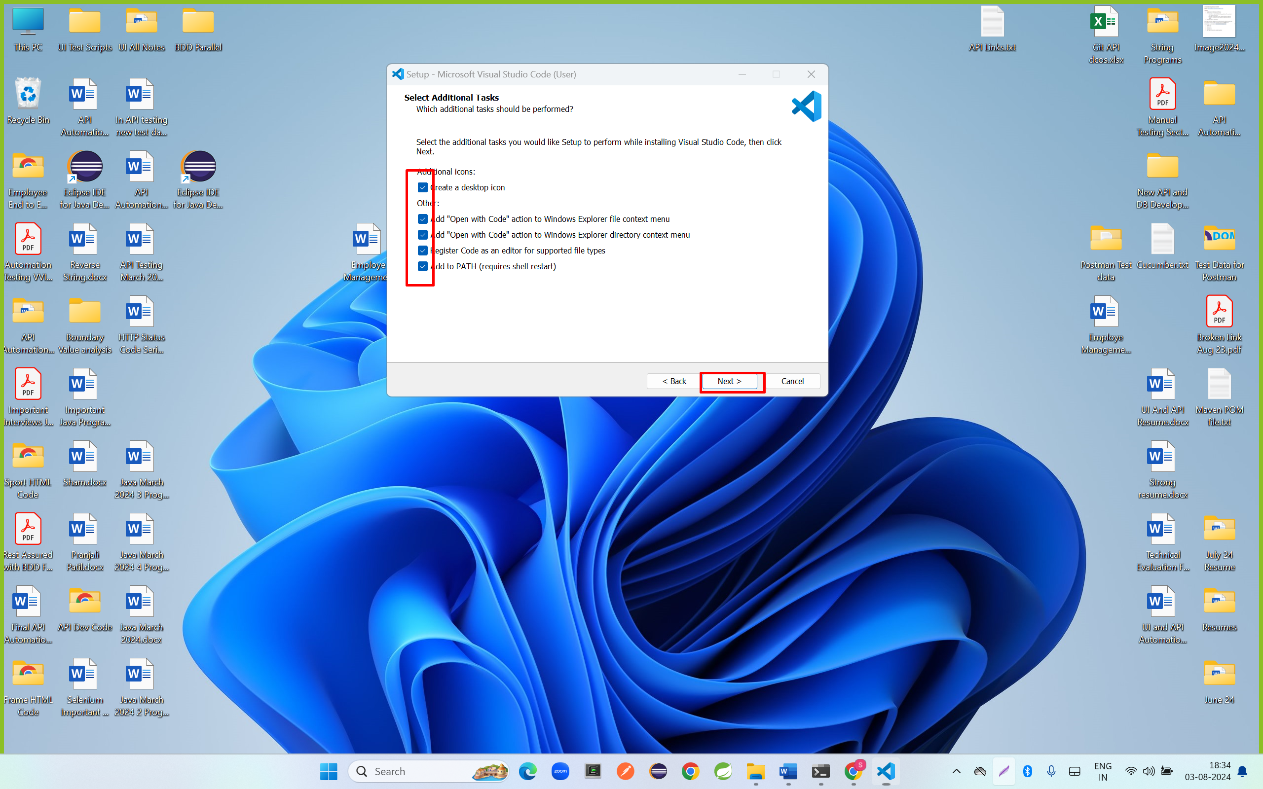

Step 6: click on install button

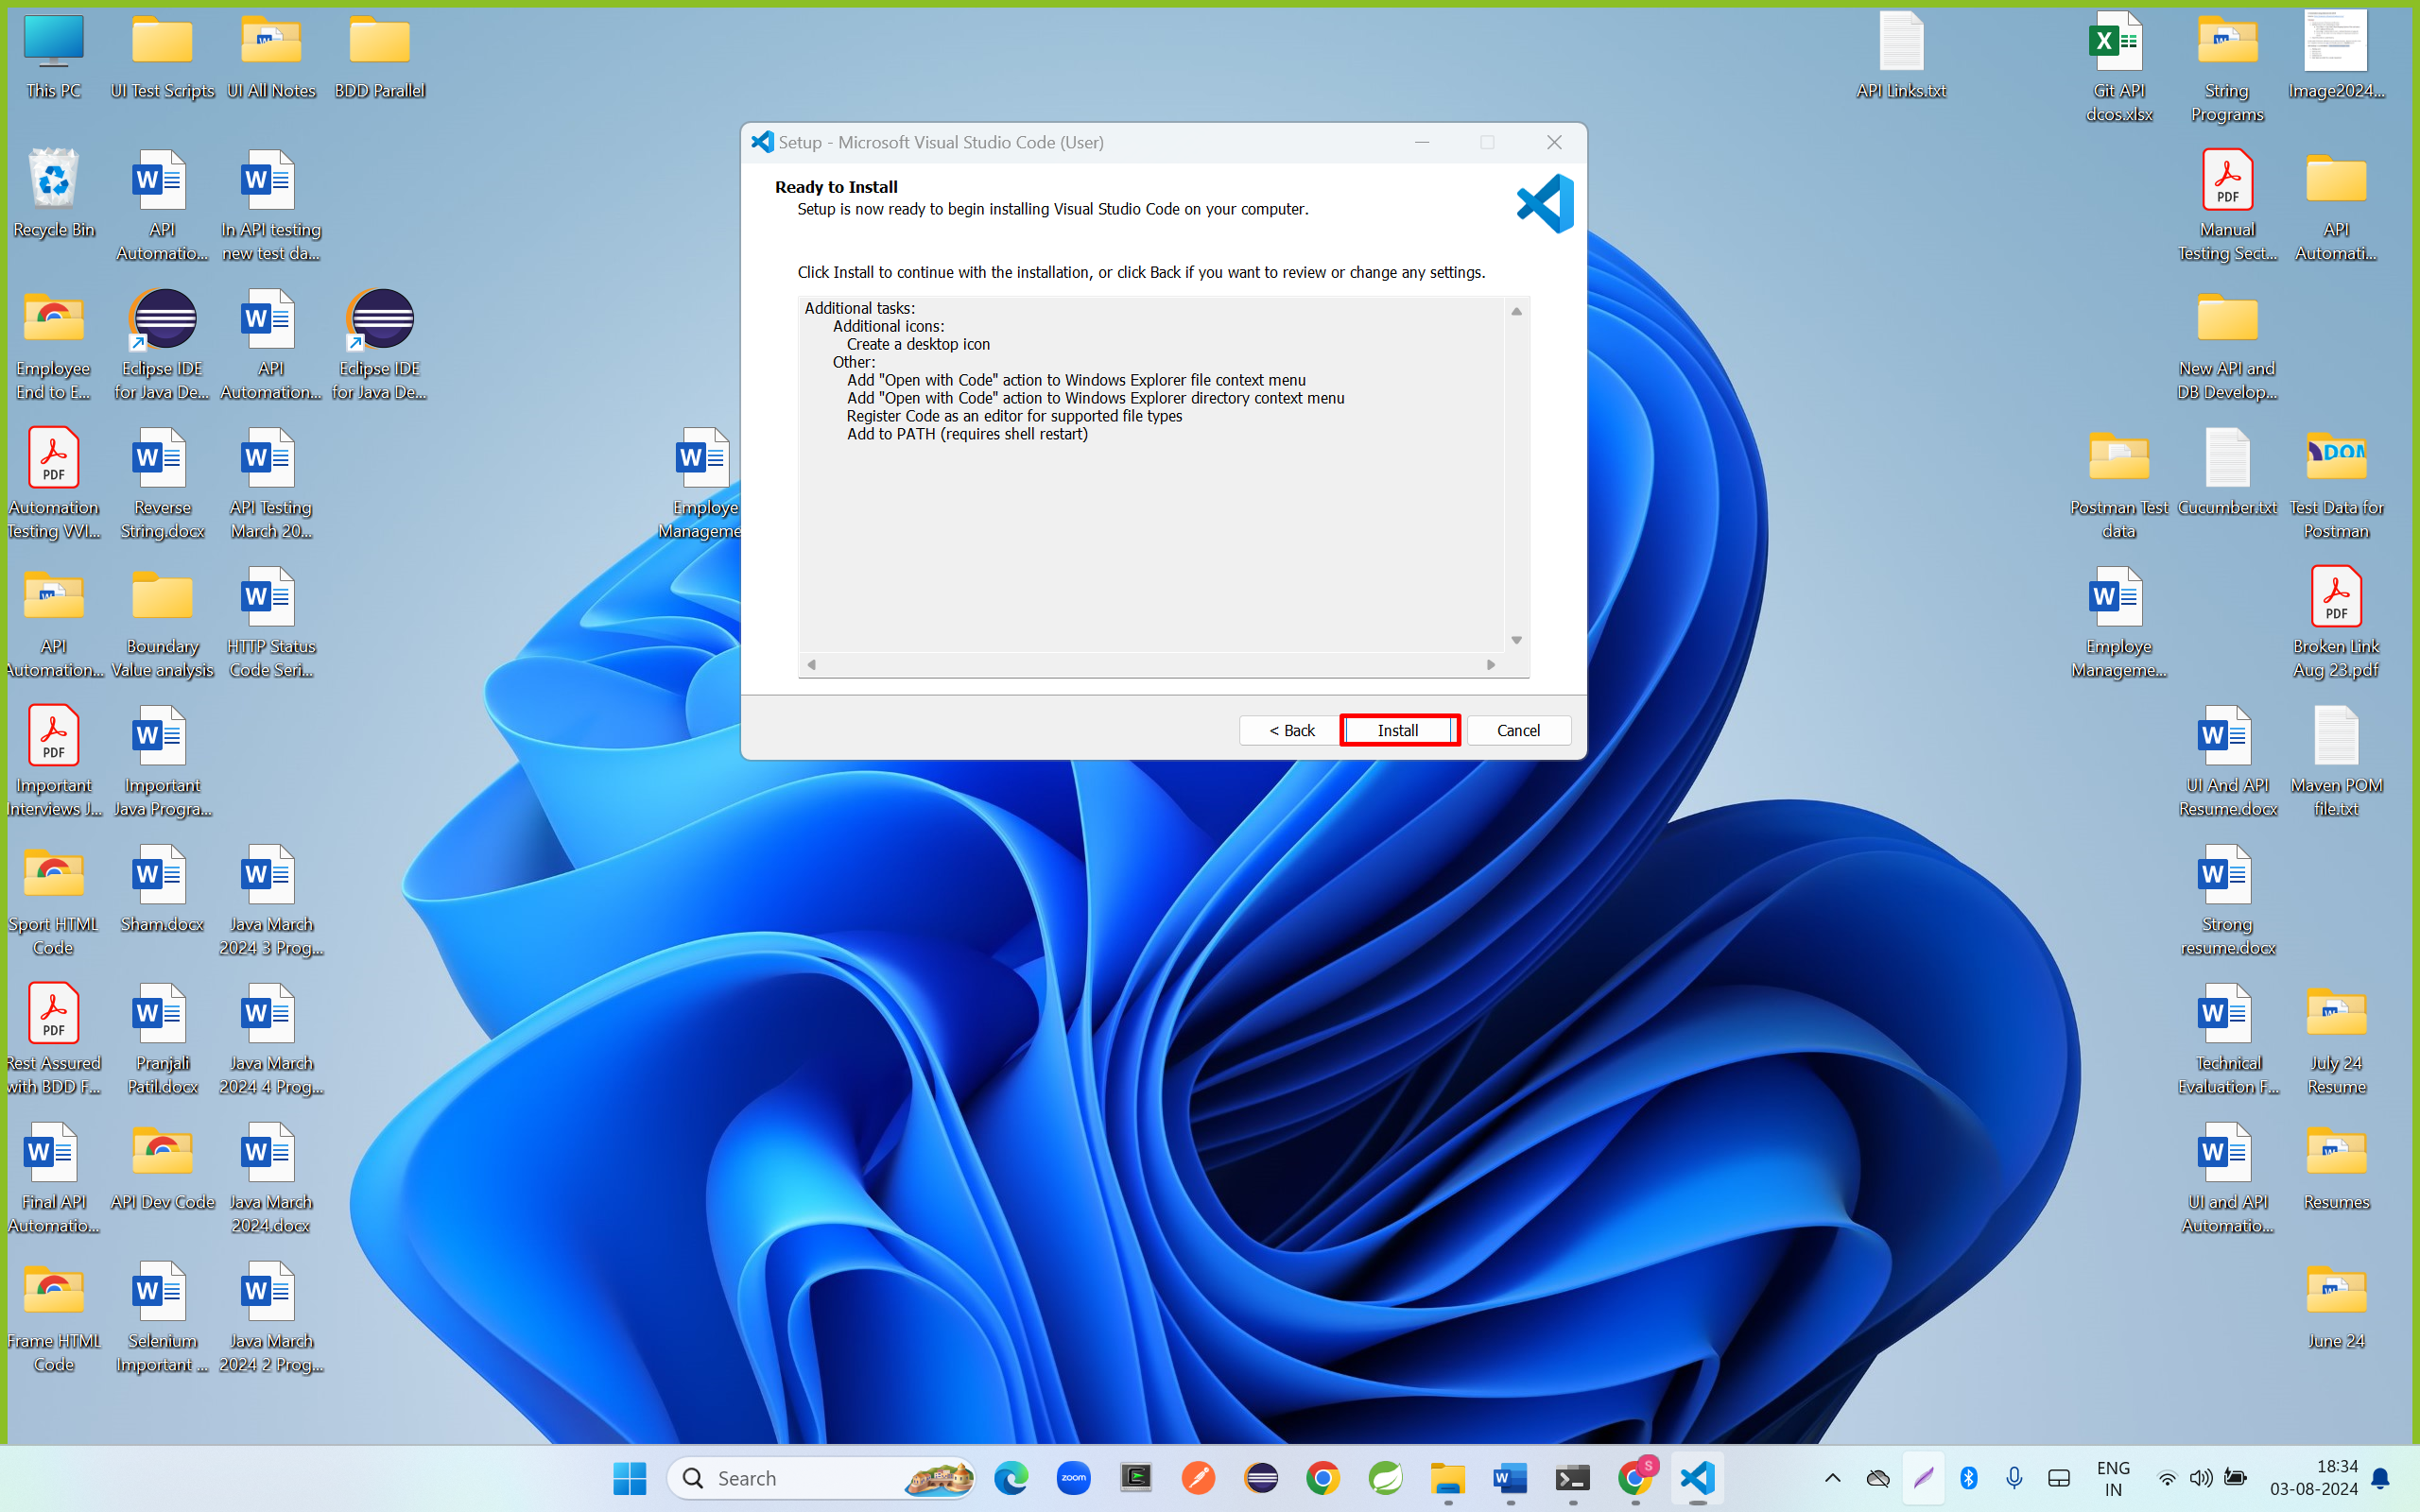

Step 7: click on finish button

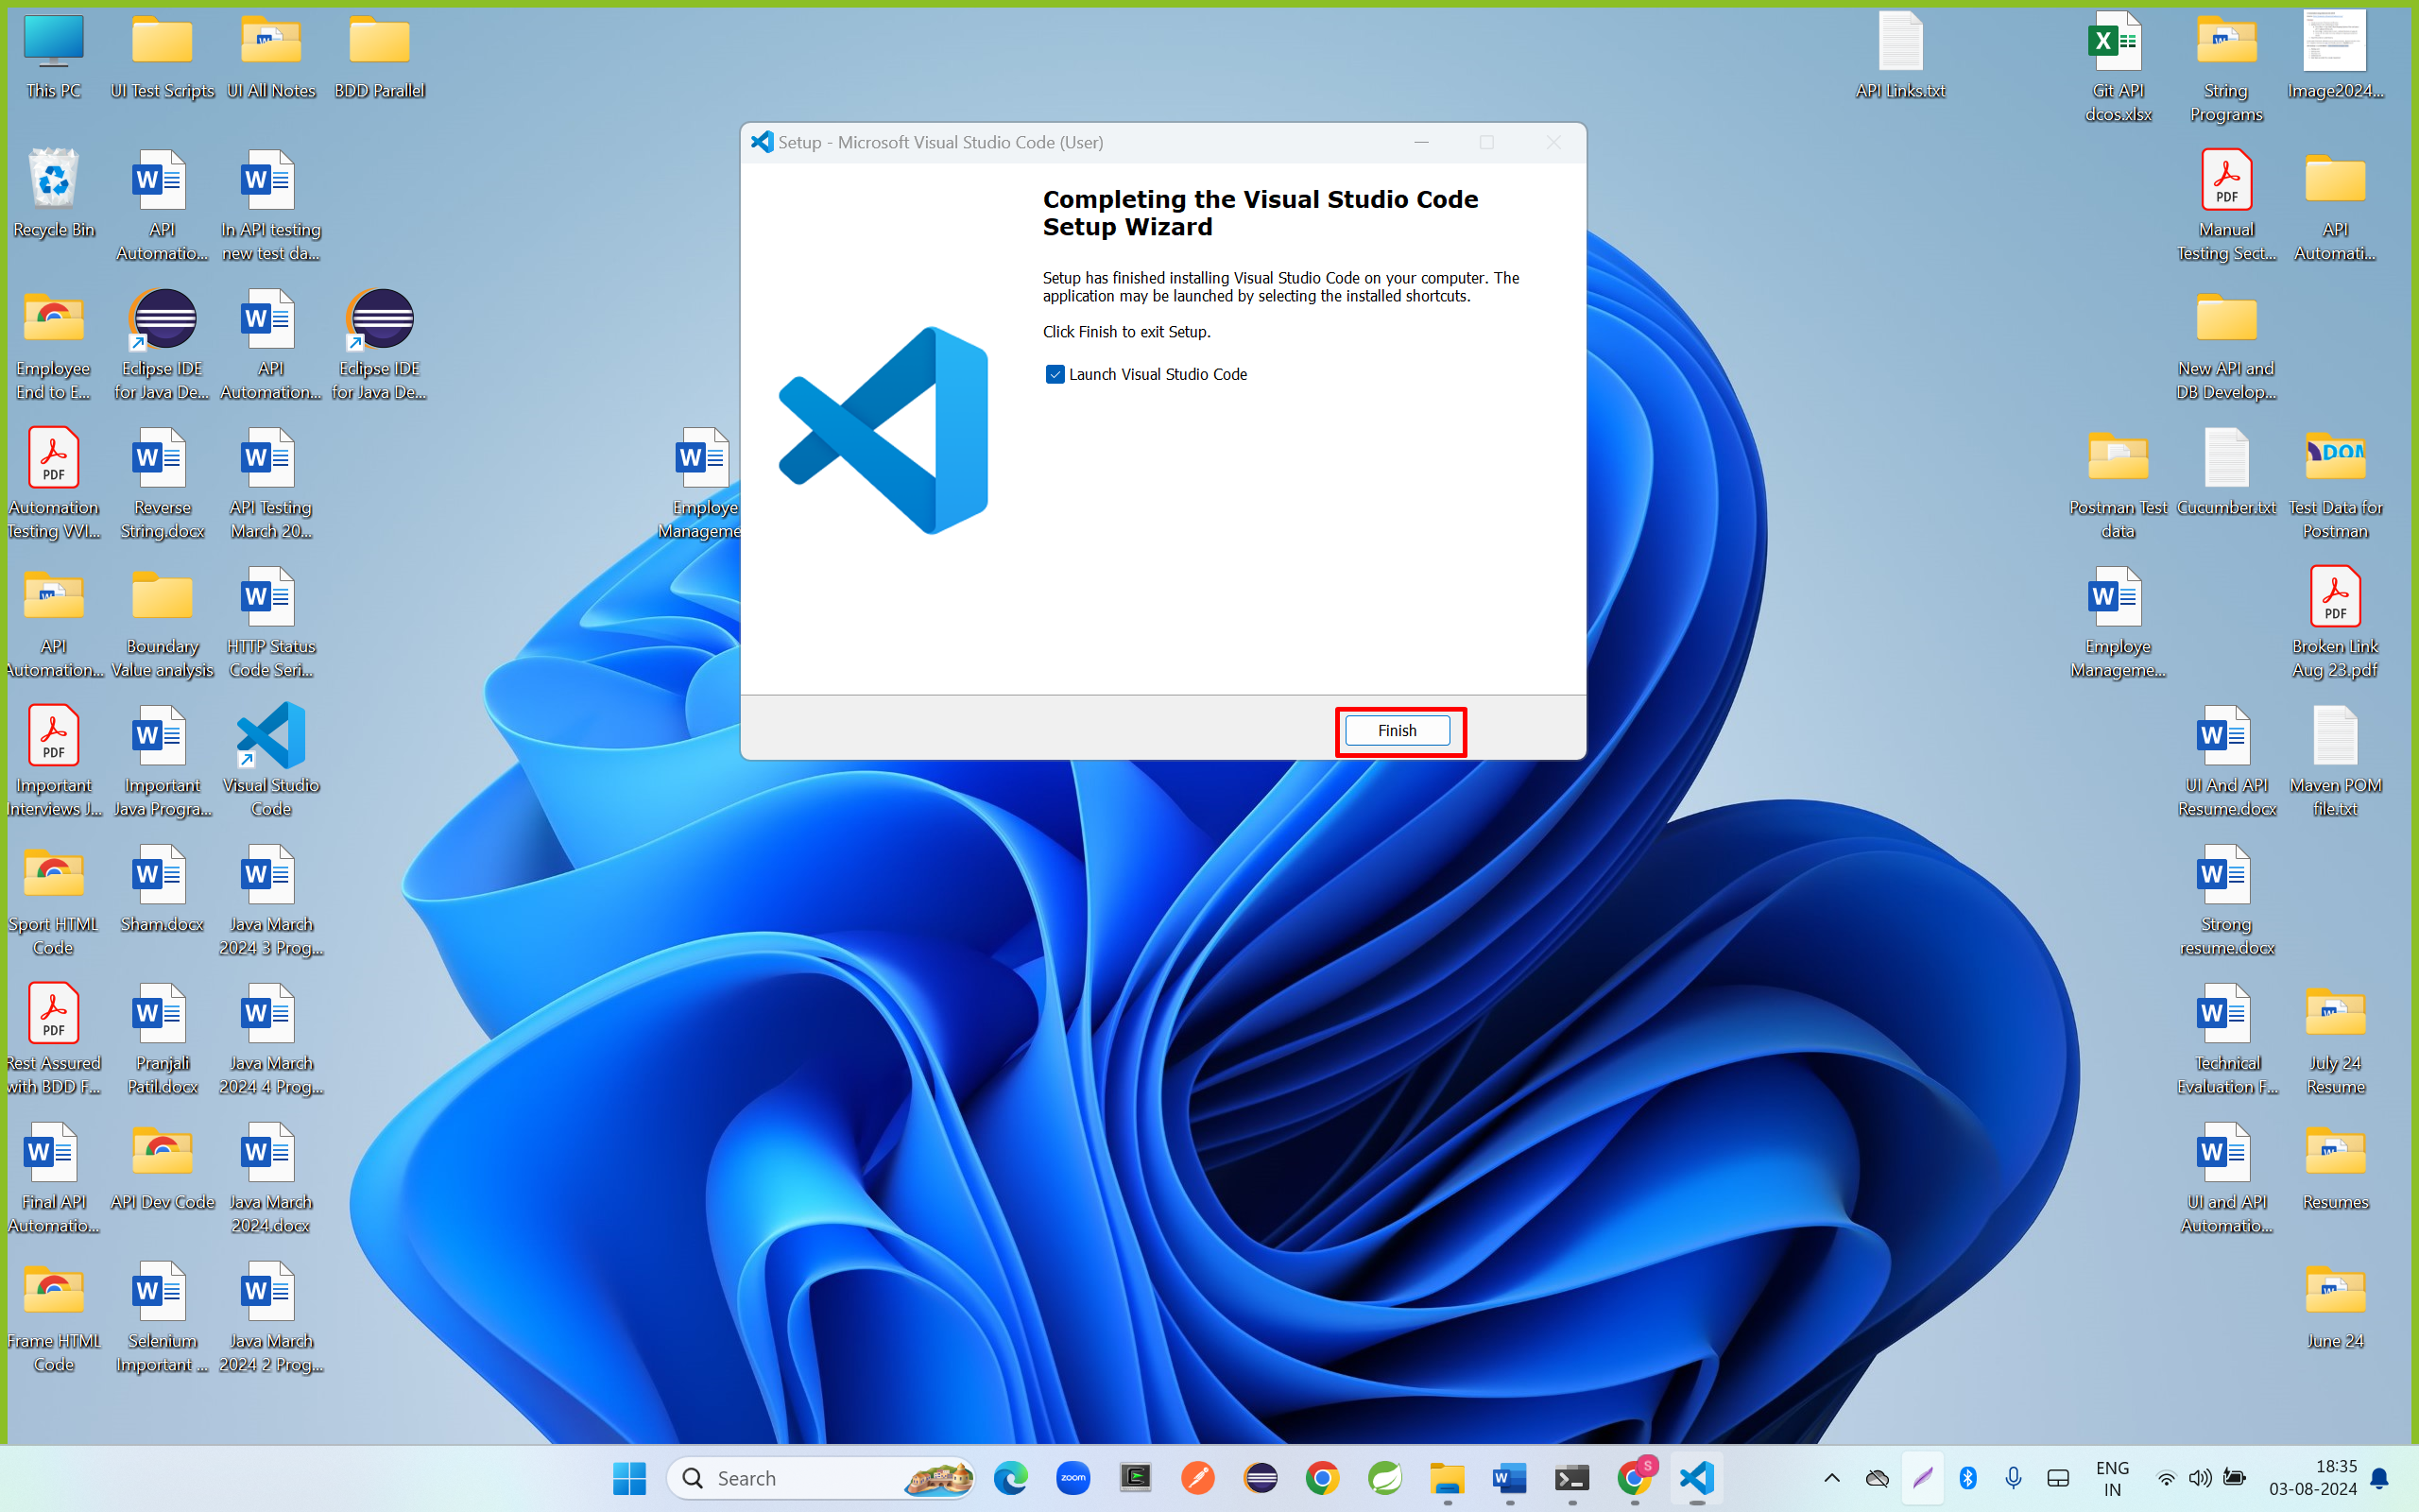

Install JSON Server

Step 1: open power shell in admin mode

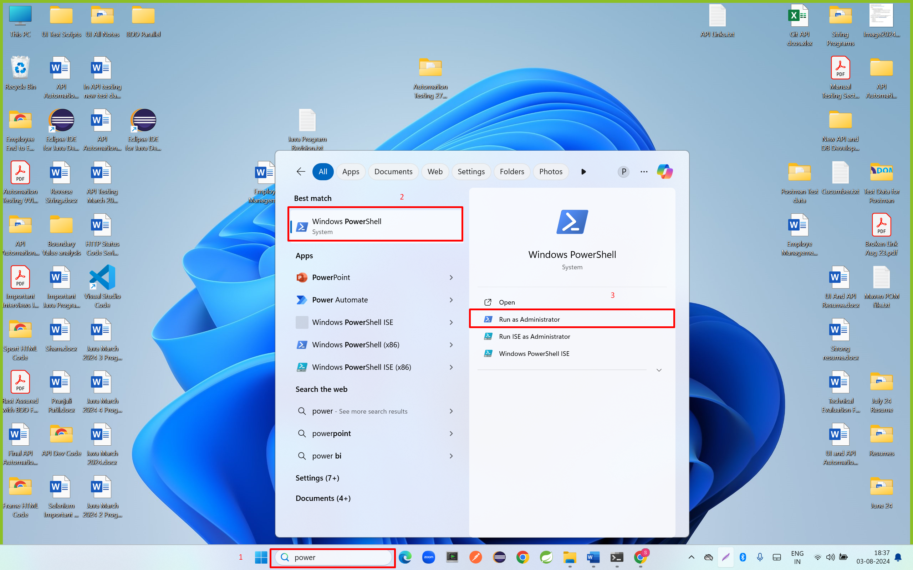

Step 2: run below command

Set-ExecutionPolicy -Scope CurrentUser Unrestricted

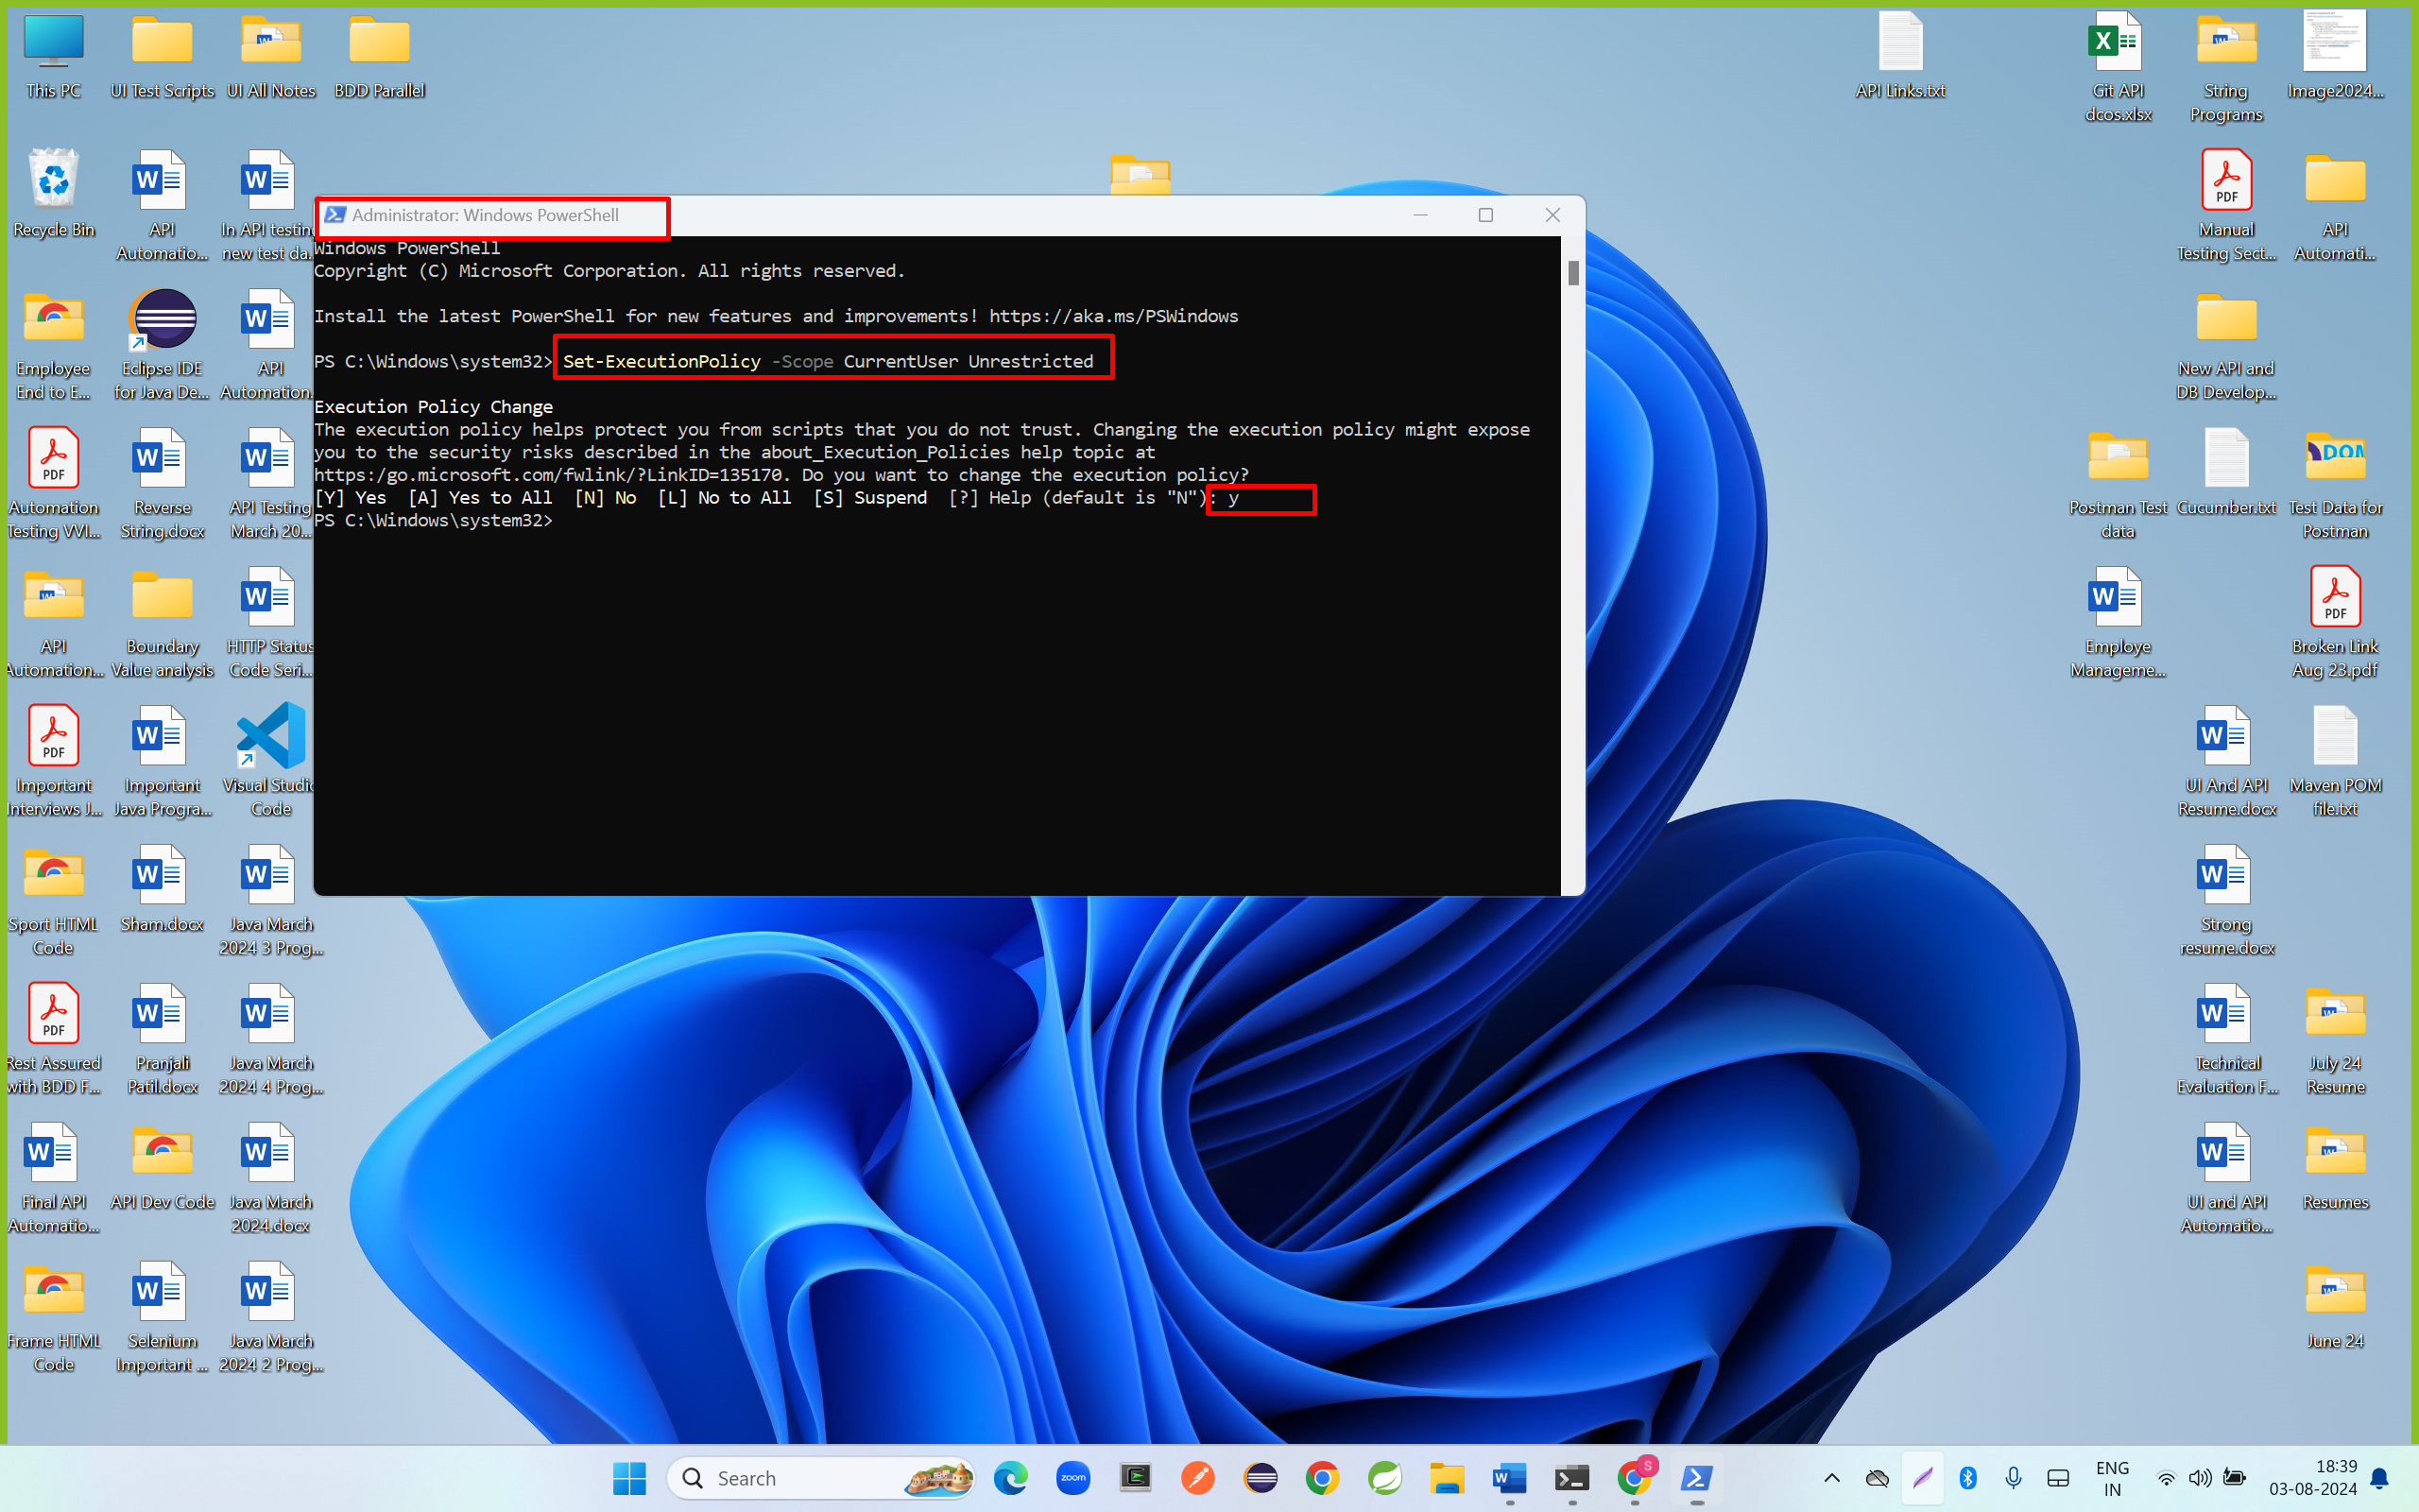

Step 3: create folder in desktop or Any Drive location

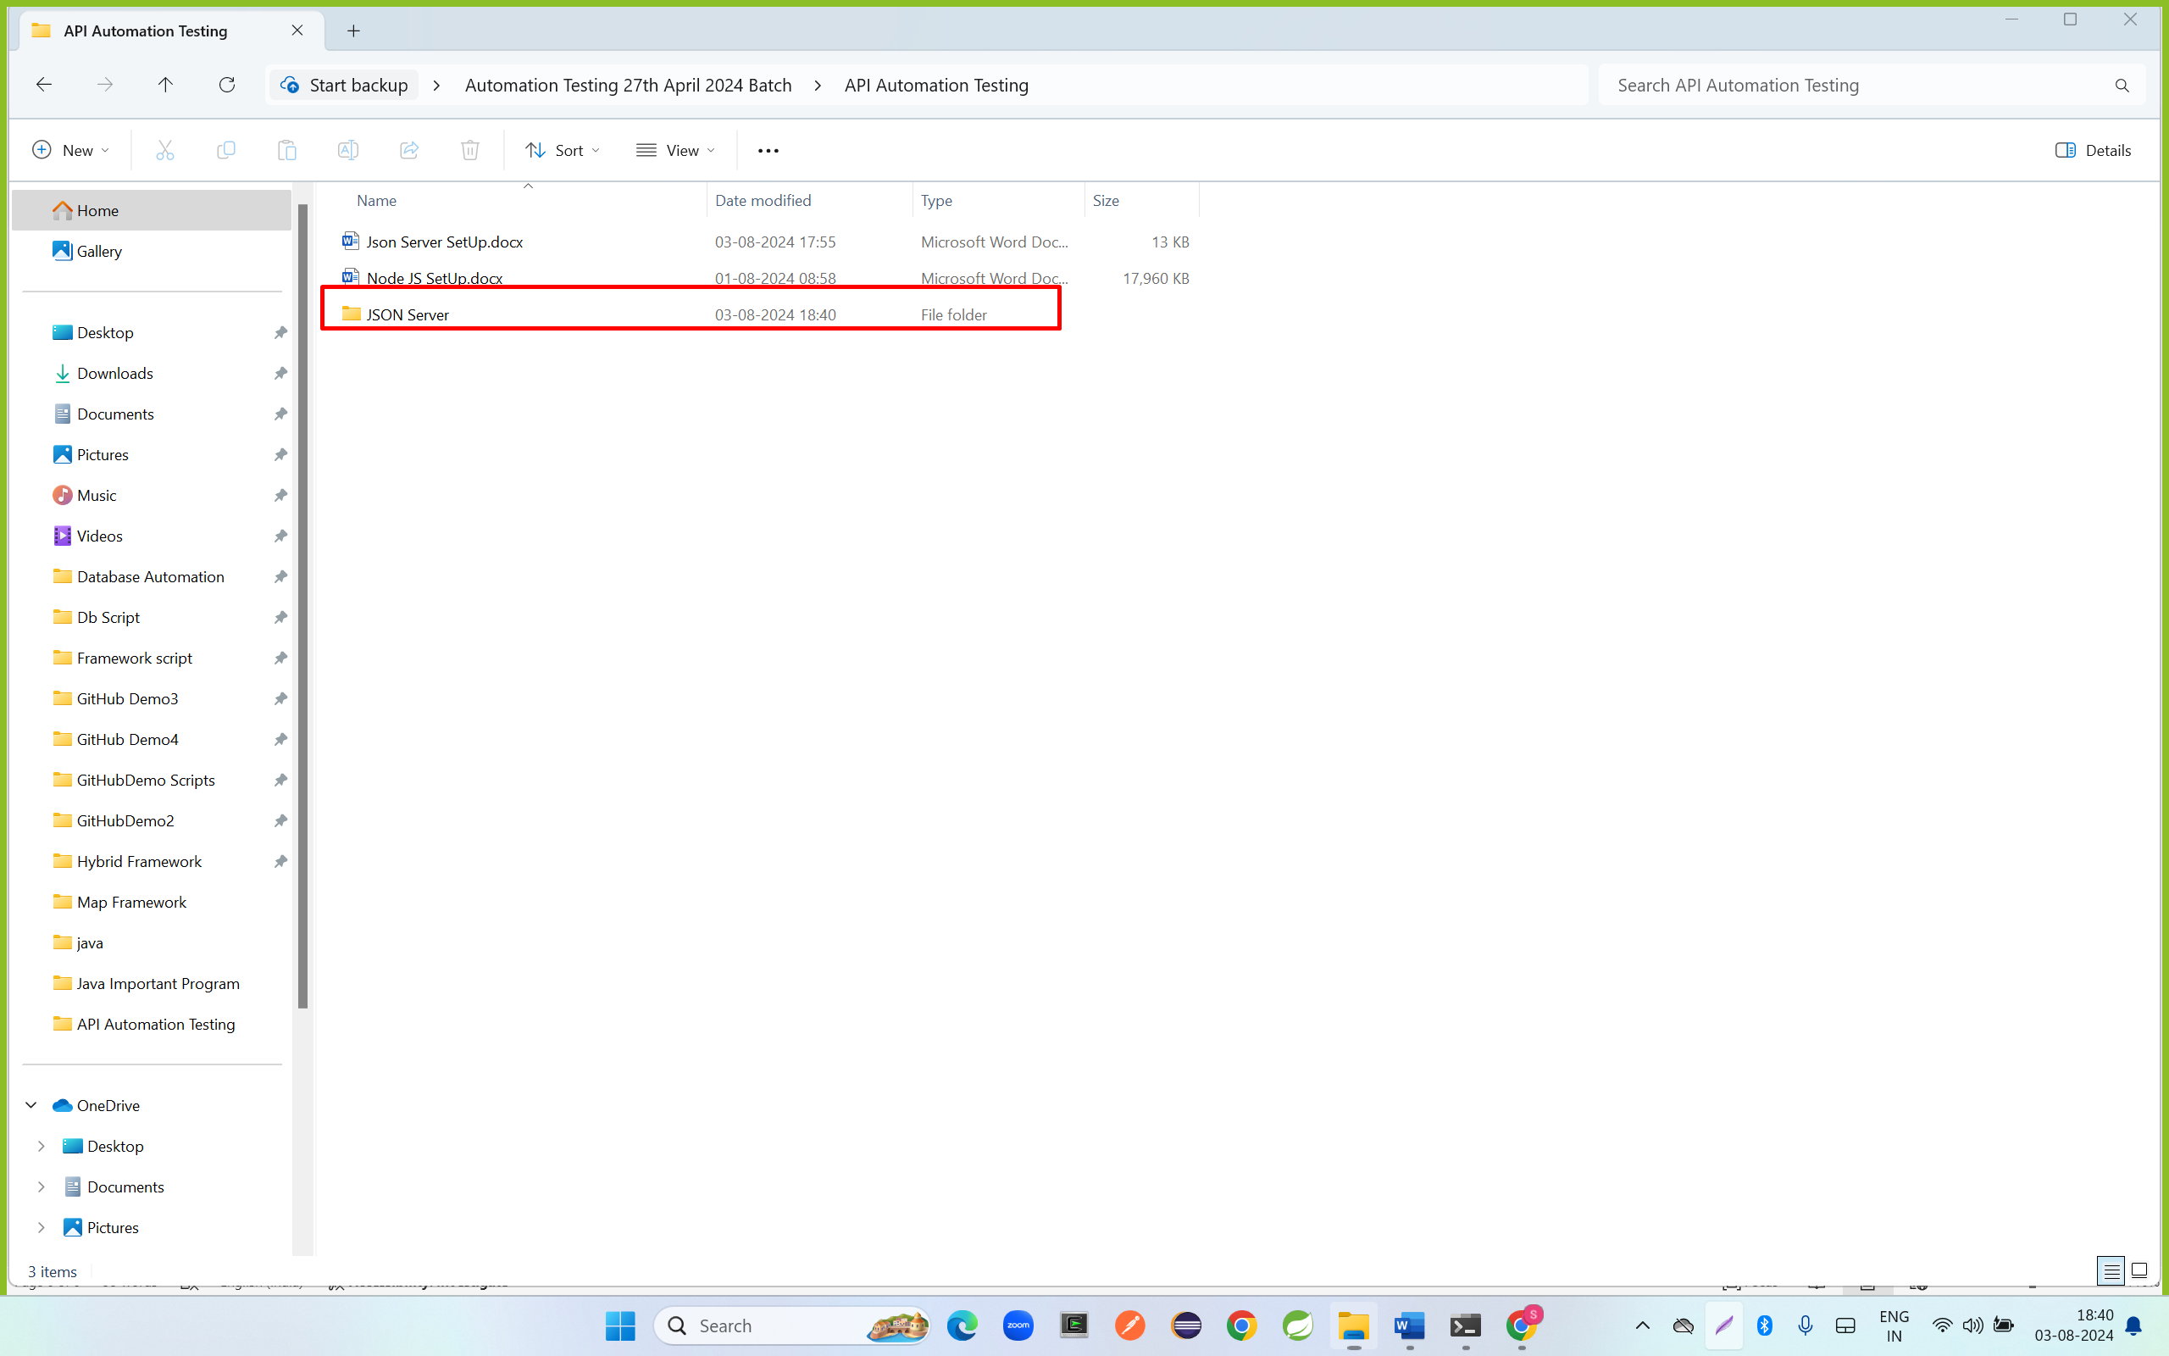

Step 3: open a folder , right click any where and click on open Code

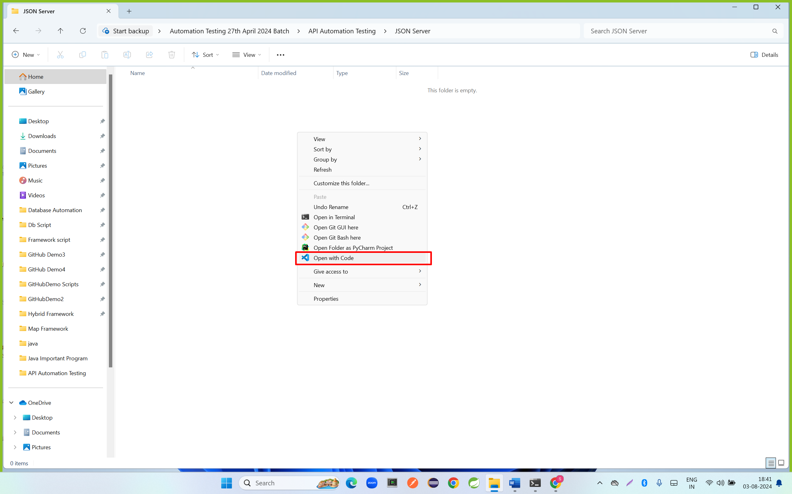

Step 4: click on + icon

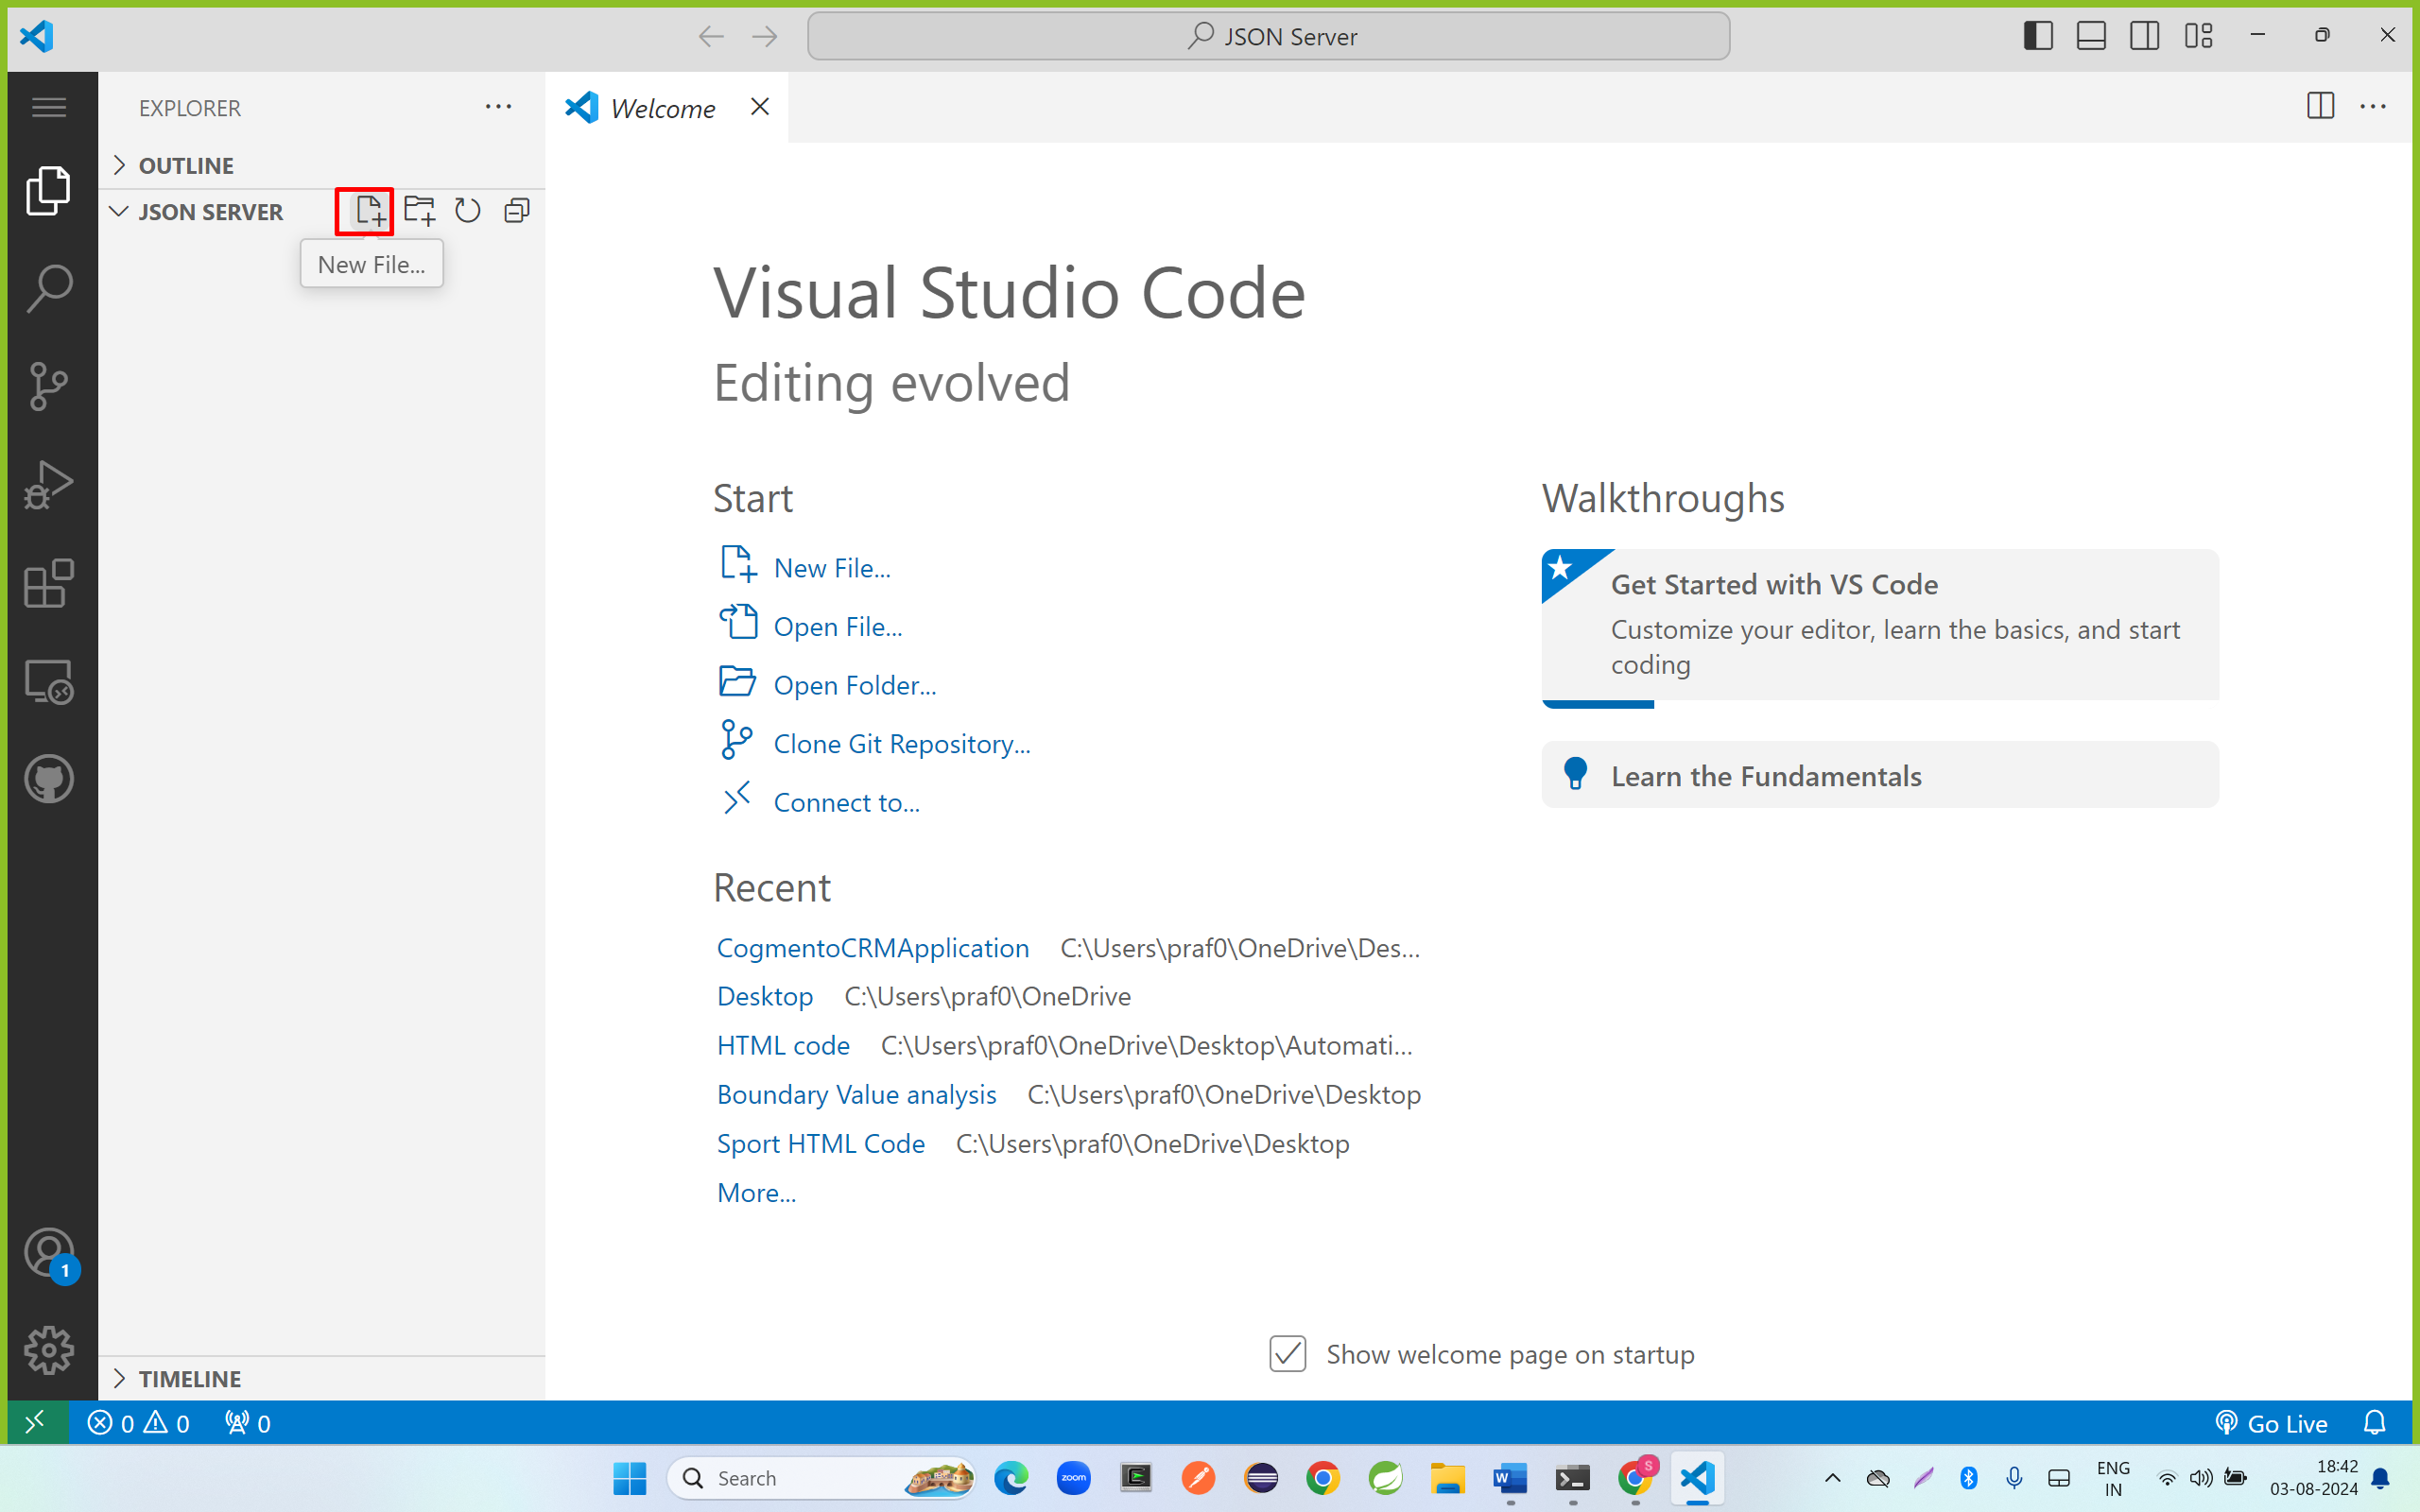

Enter db.json file name and copy the below JSON format and save db.json file

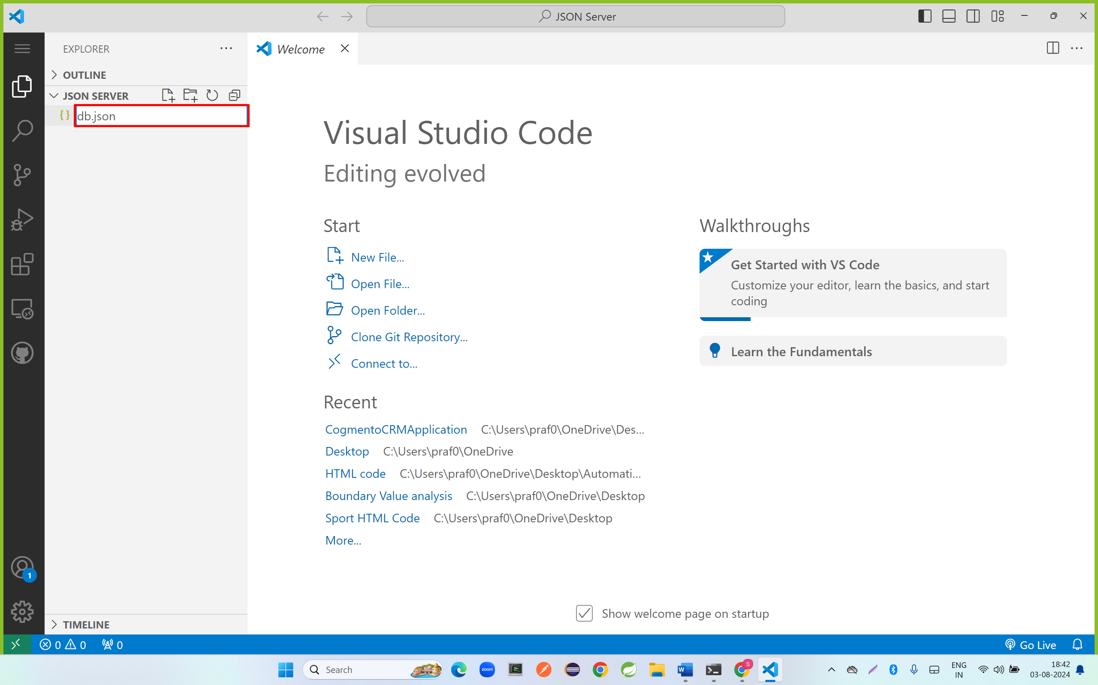

|  |
| --- |
| {      "employees" :      [          {              "id" : 1,              "firstName" : "Anjali",              "lastname" : "Patil",              "address" : "Pune",              "mobileNumber" : 90909090,              "gender" : "female"          },          {              "id" : 2,              "firstName" : "Rohit",              "lastname" : "Sathe",              "address" : "Mumbai",              "mobileNumber" : 80808080,              "gender" : "male"          }      ]  } |

Step 5: click on below icon

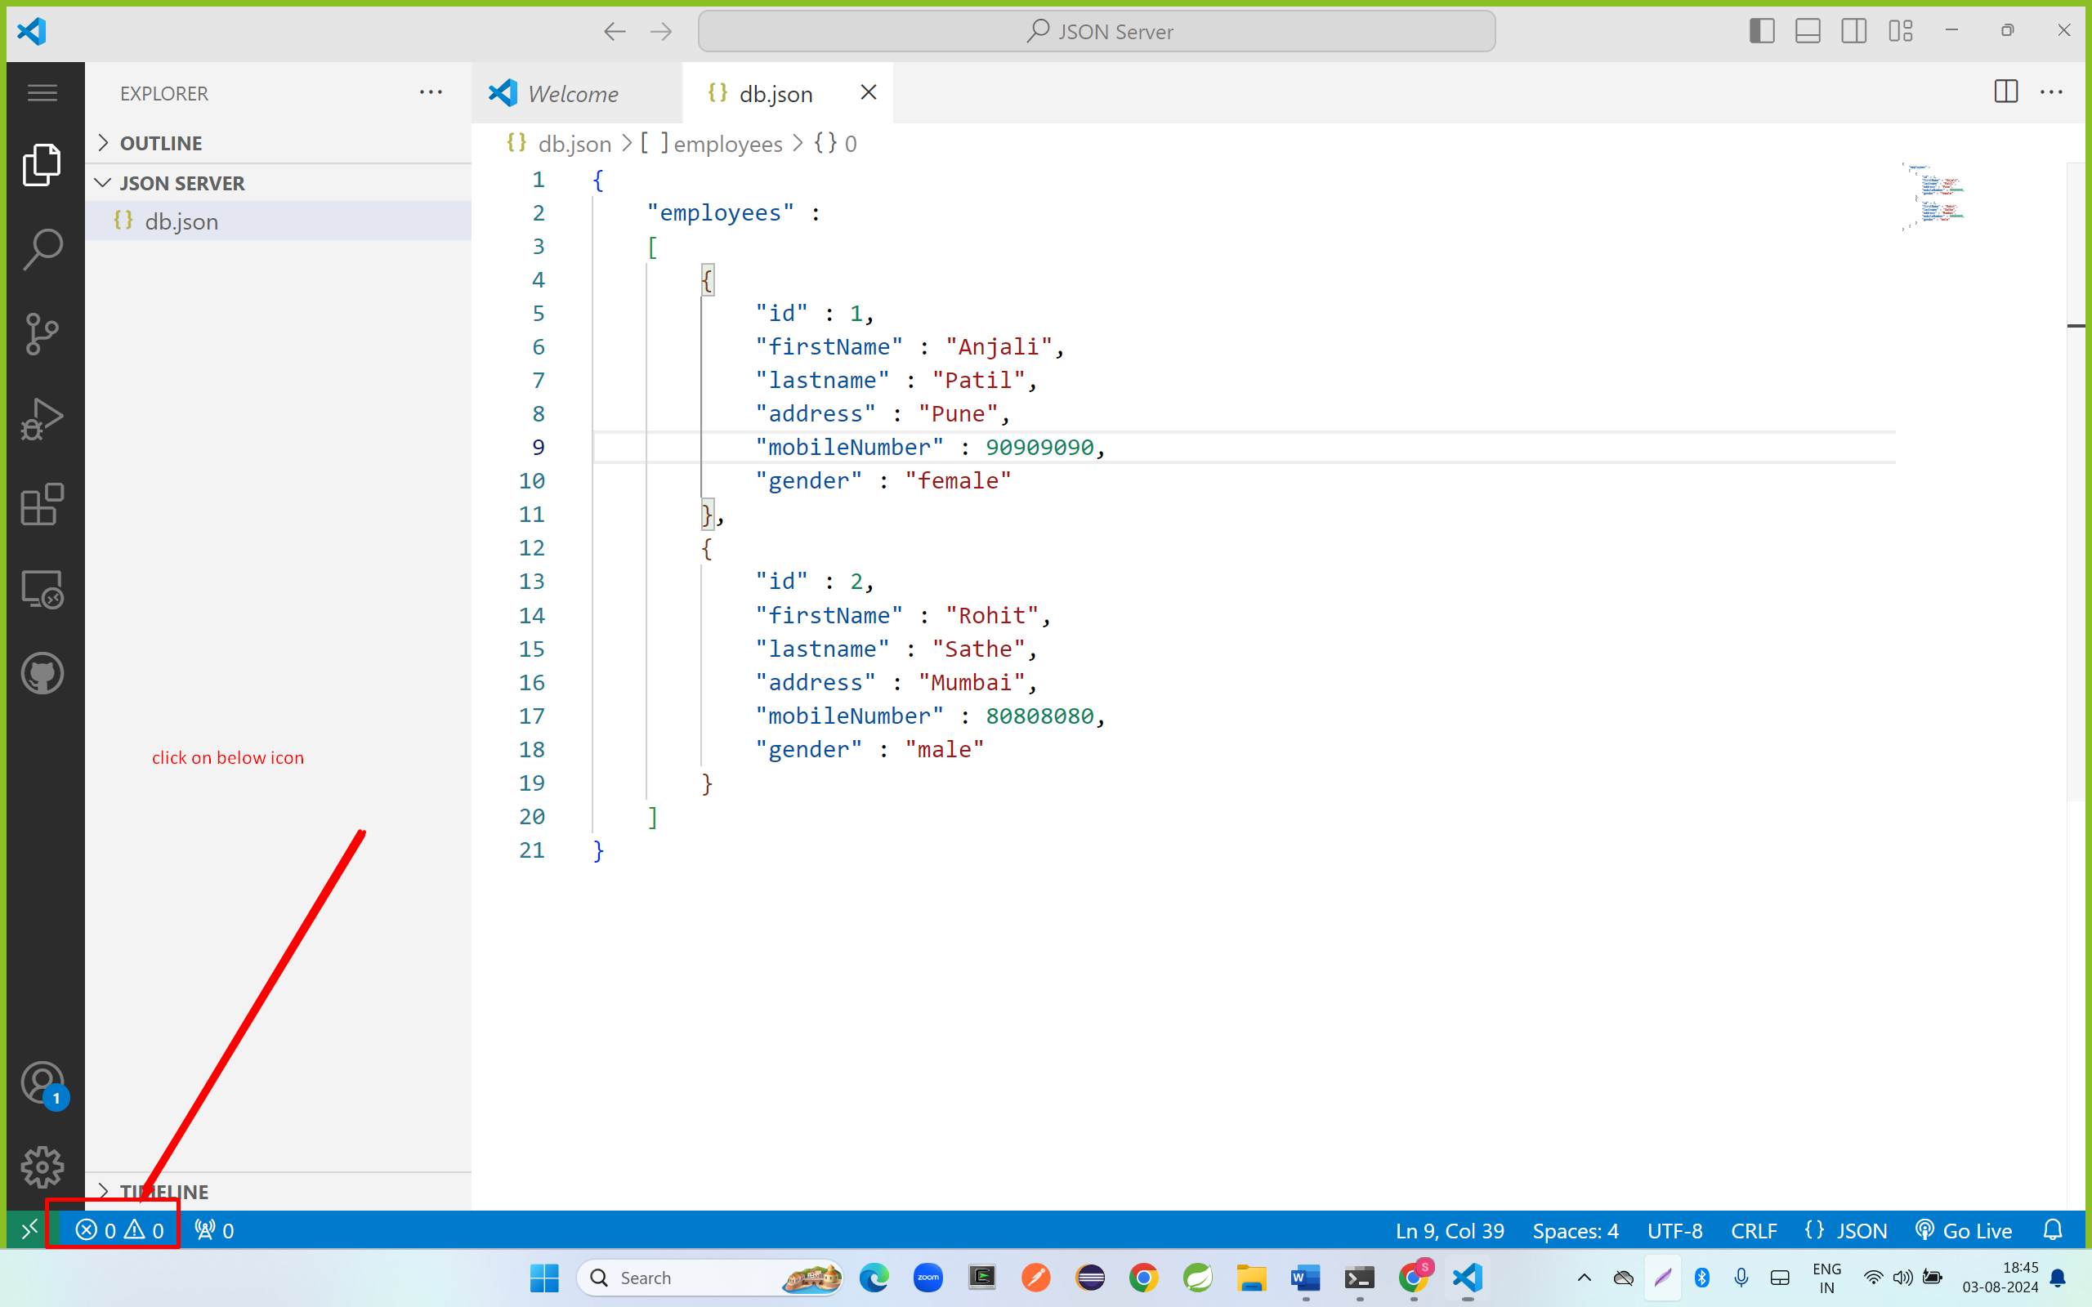

Step 6: click on terminal

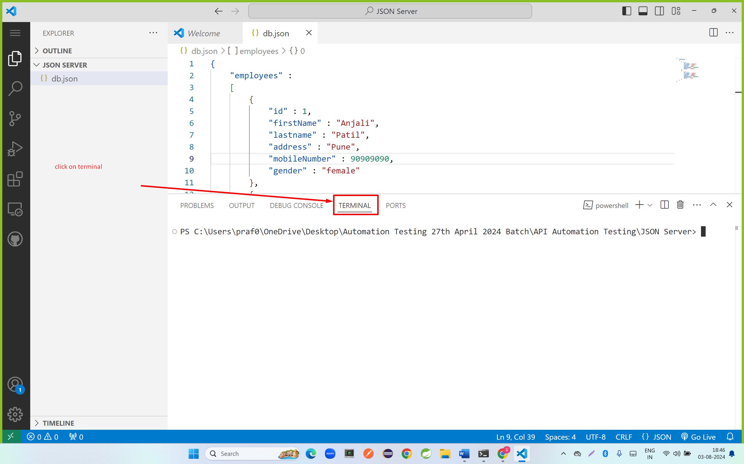

Step 7: run below command

npm install -g json-server

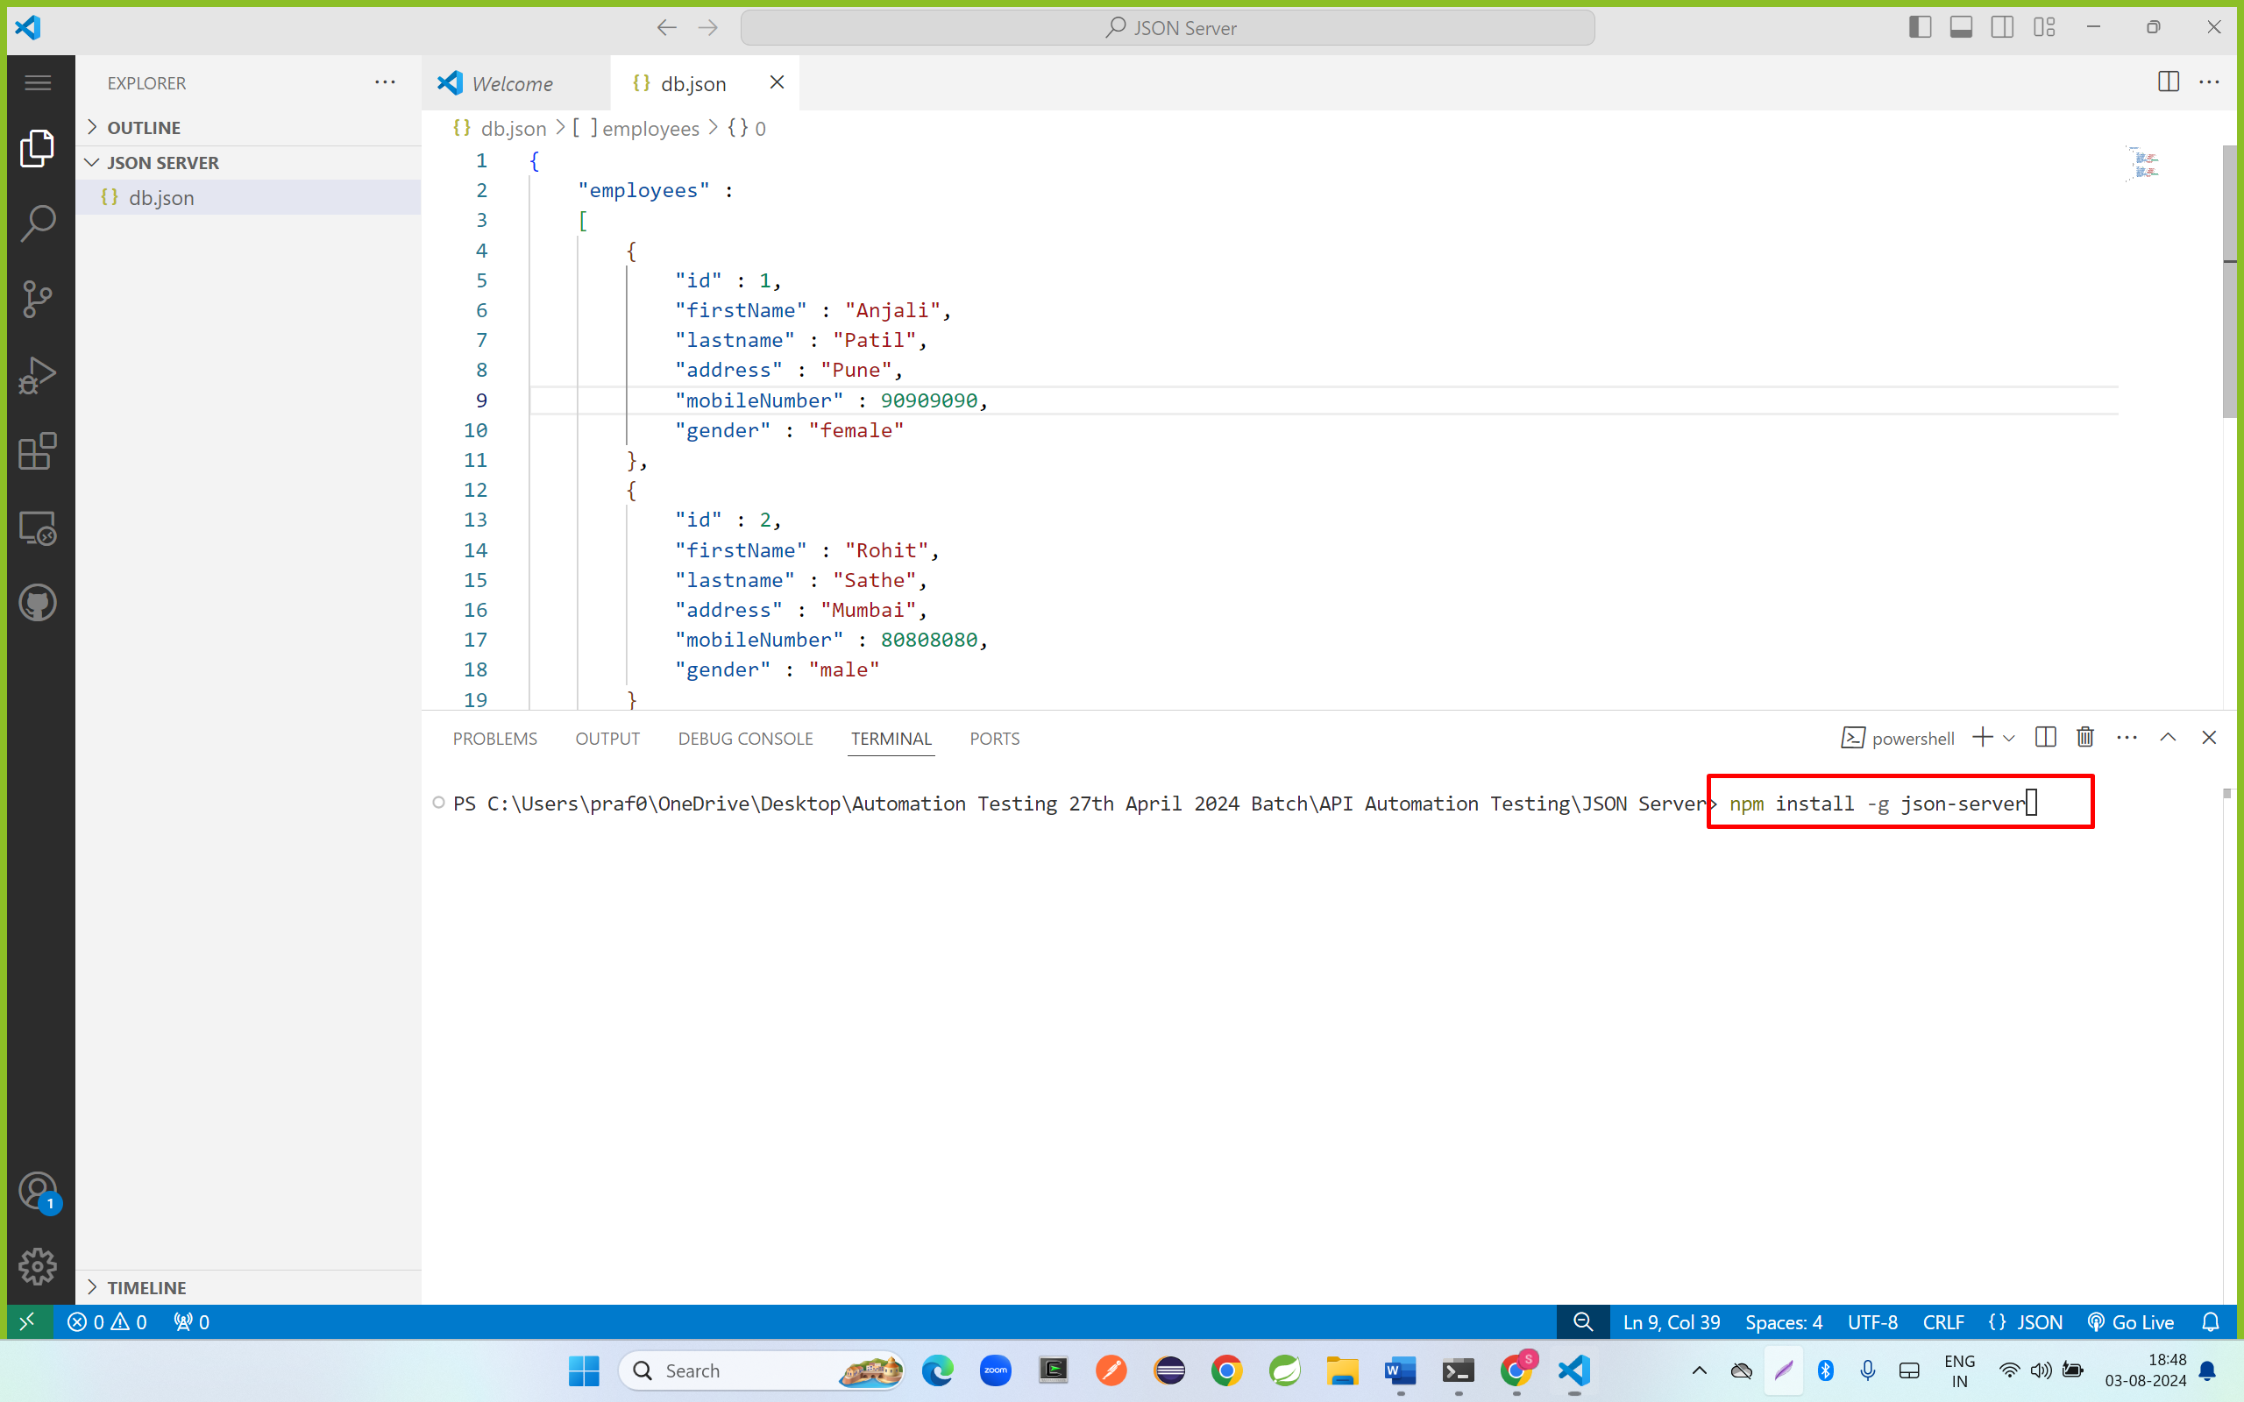

Step 8: run below command

json-server --watch db.json

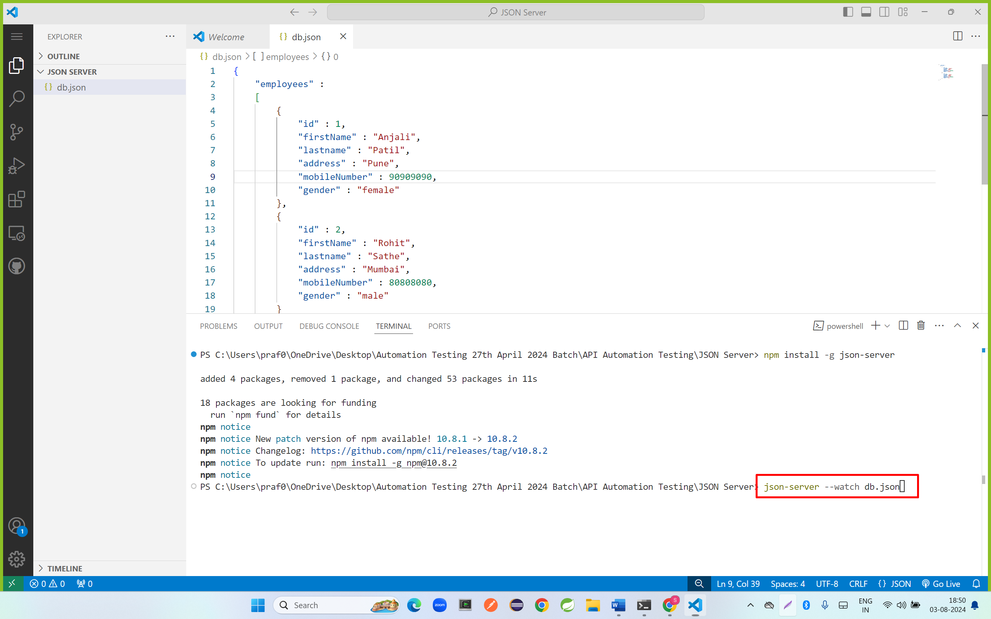

Step 9: copy the url and open in browser

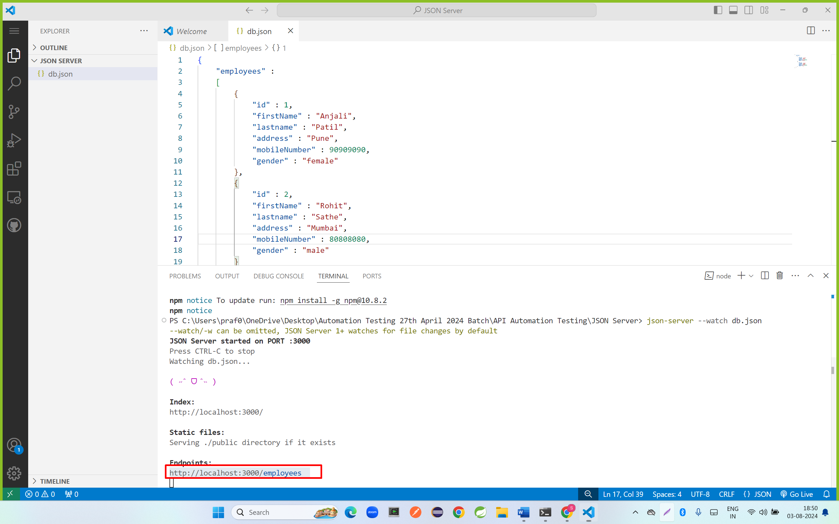

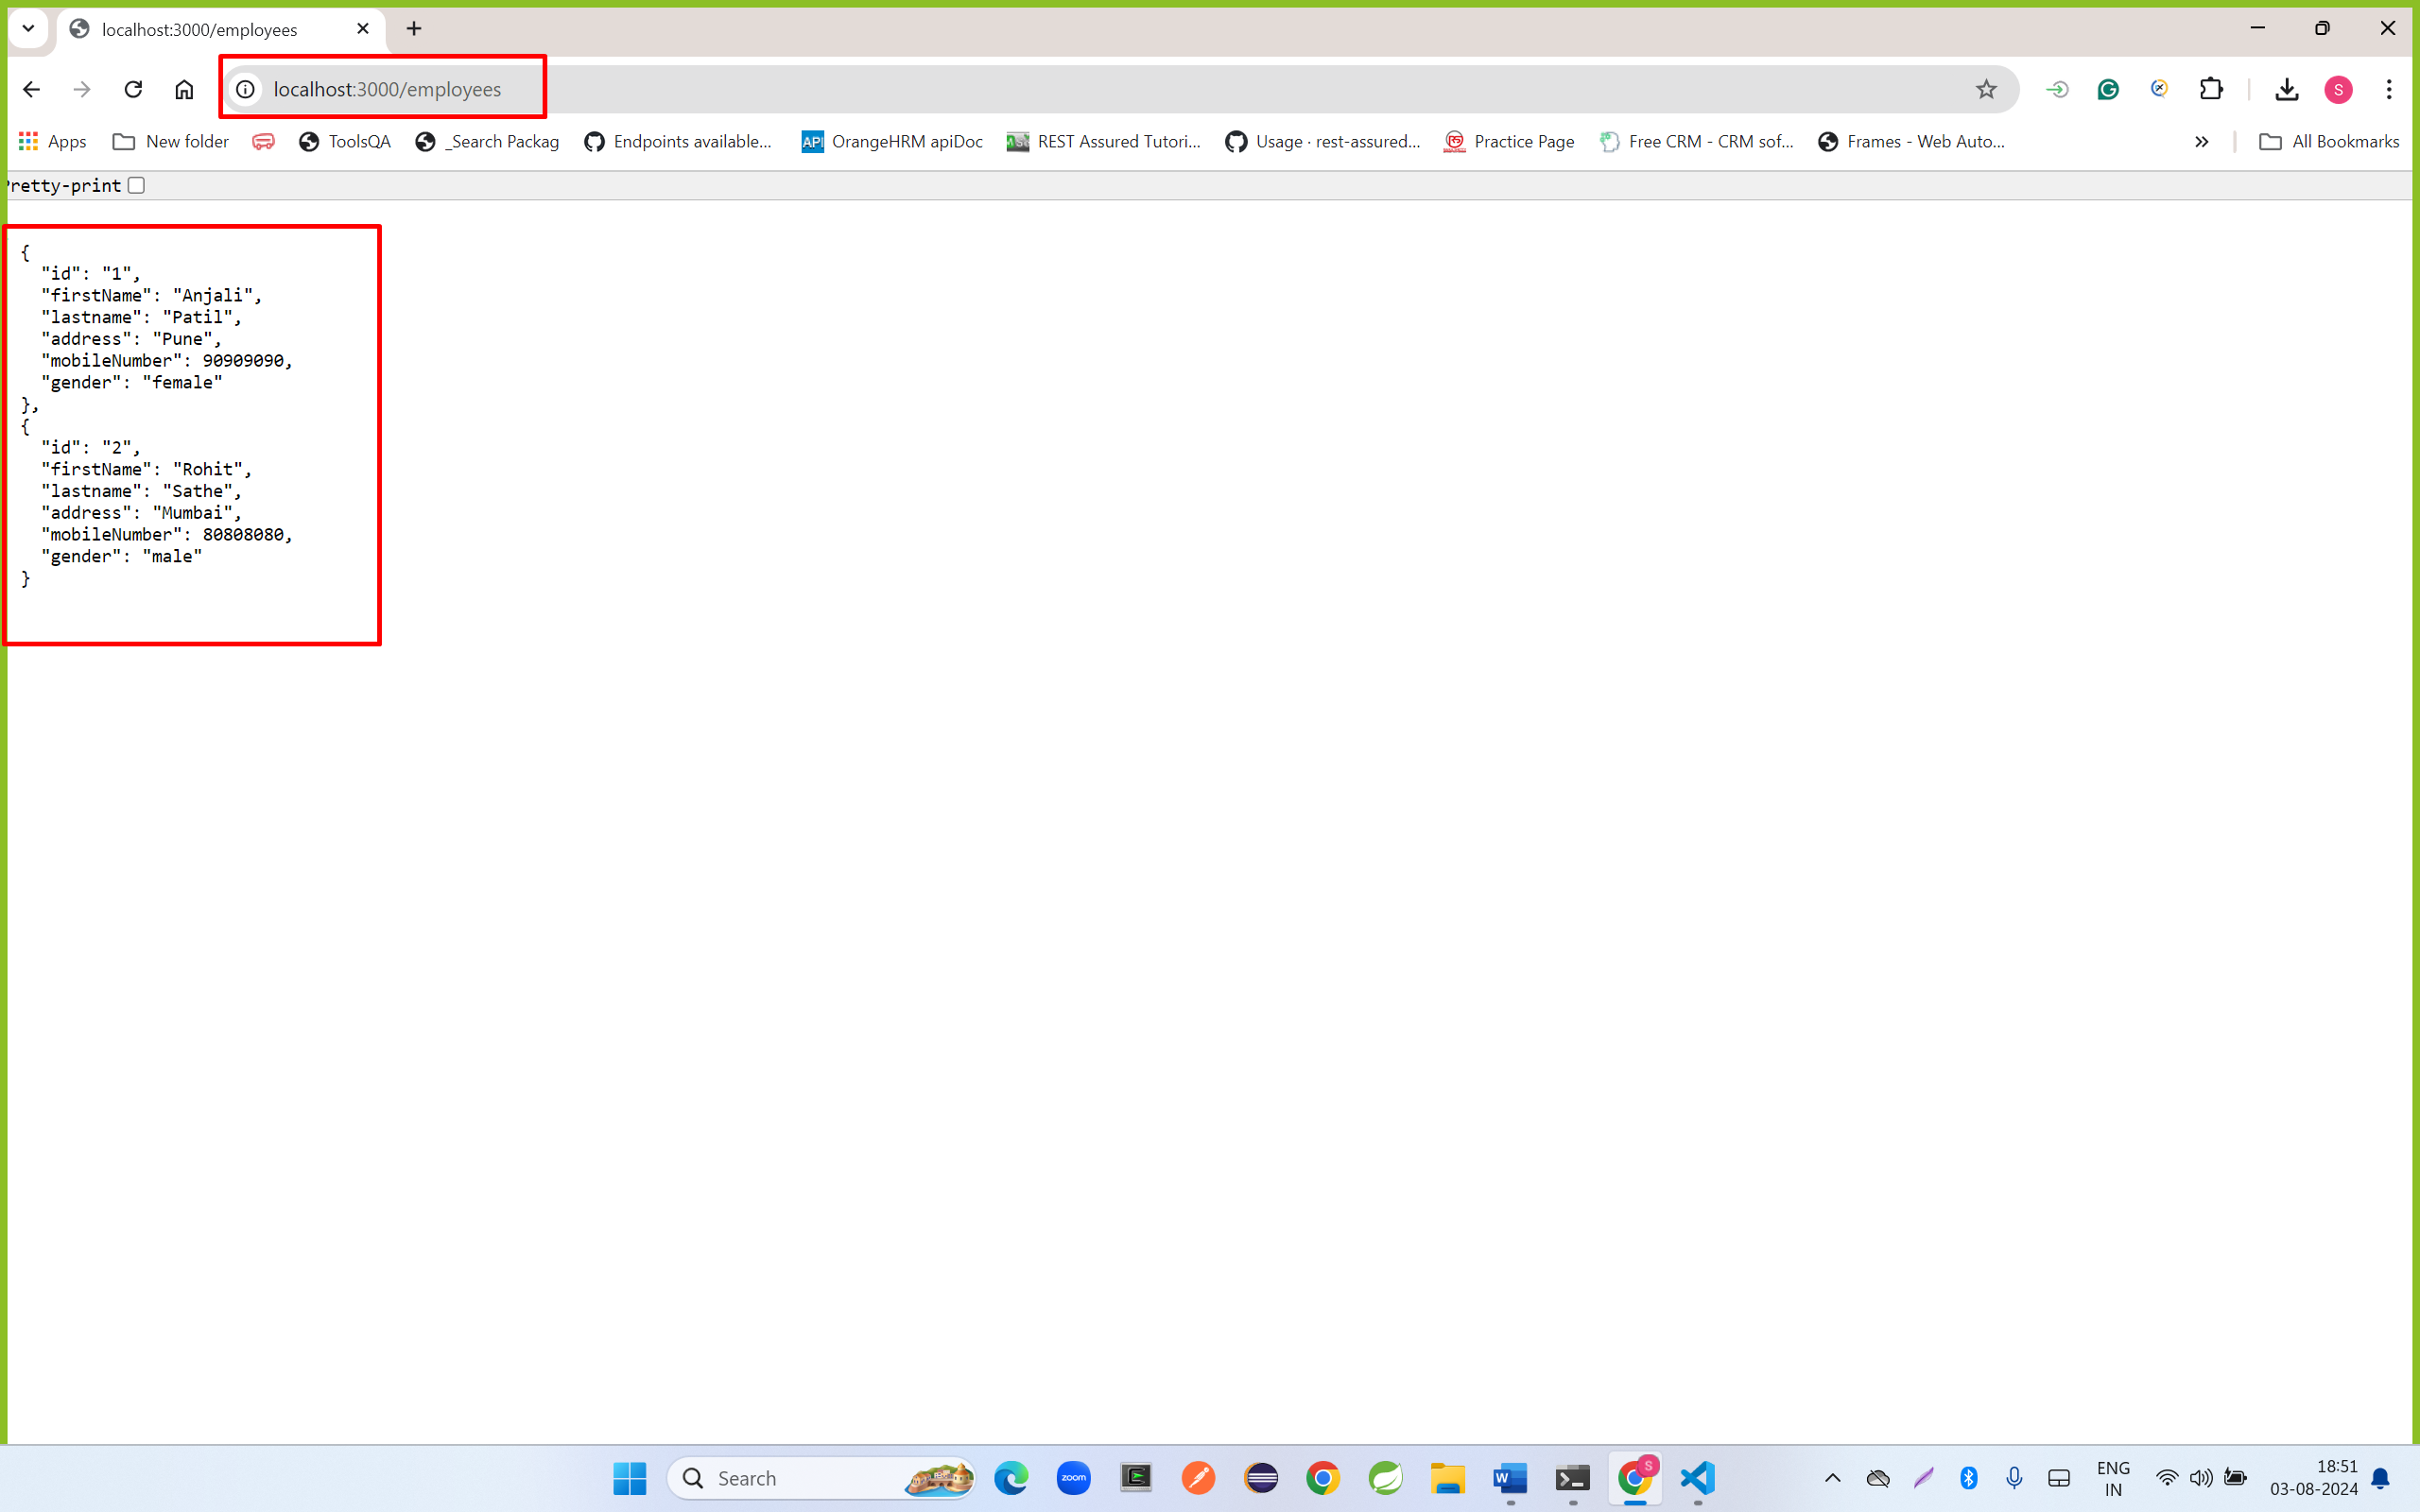

Step 10: install JSON Formater plugins

Search json format chrome plugin

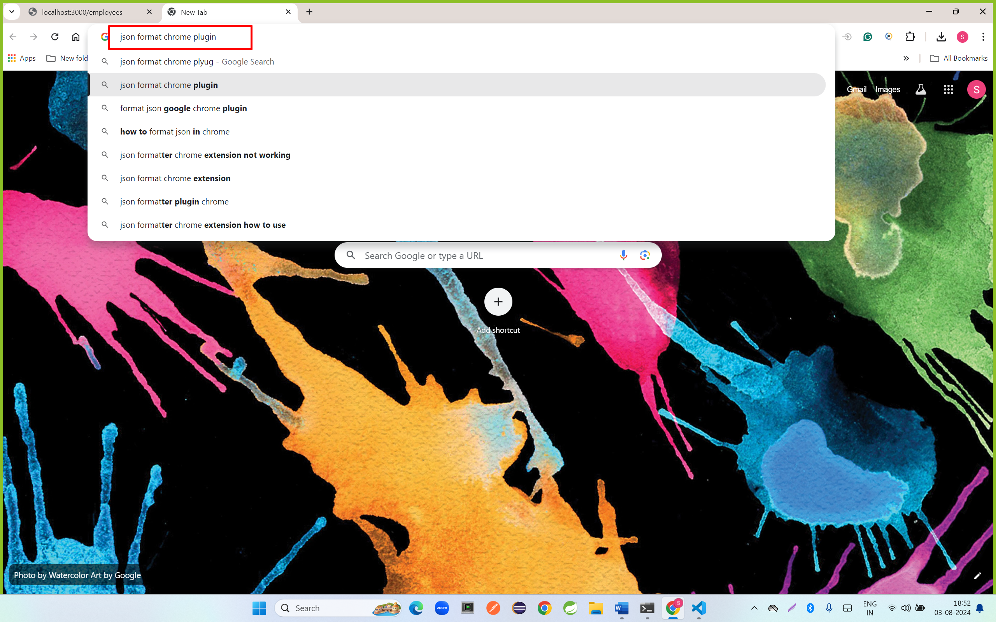

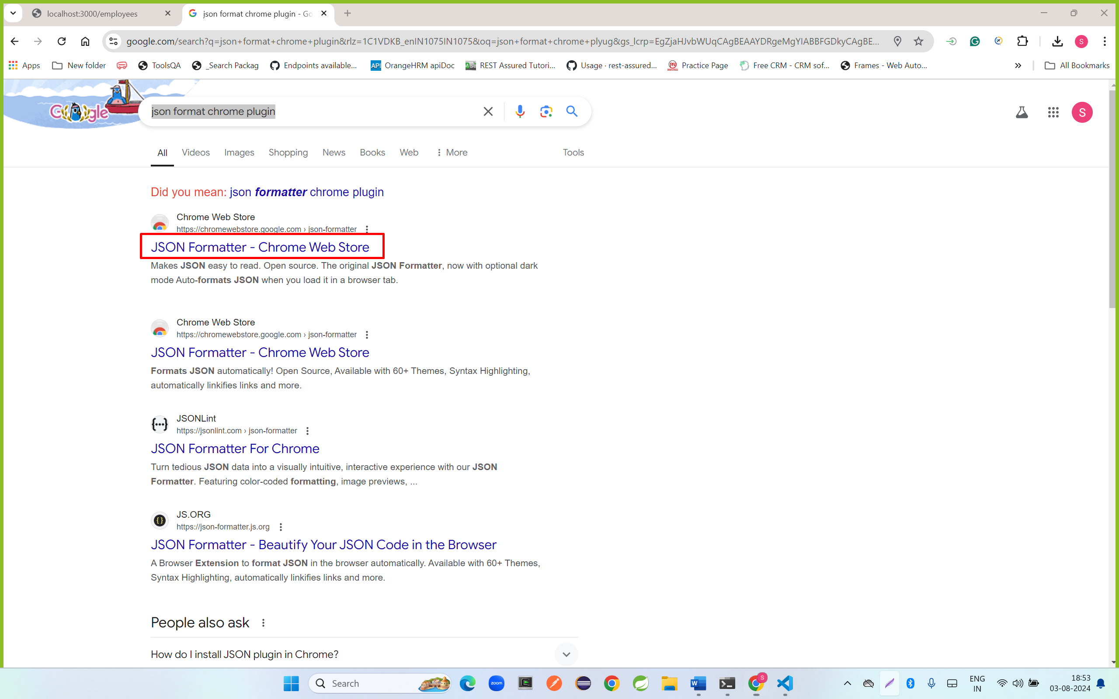

Click on add to chrome

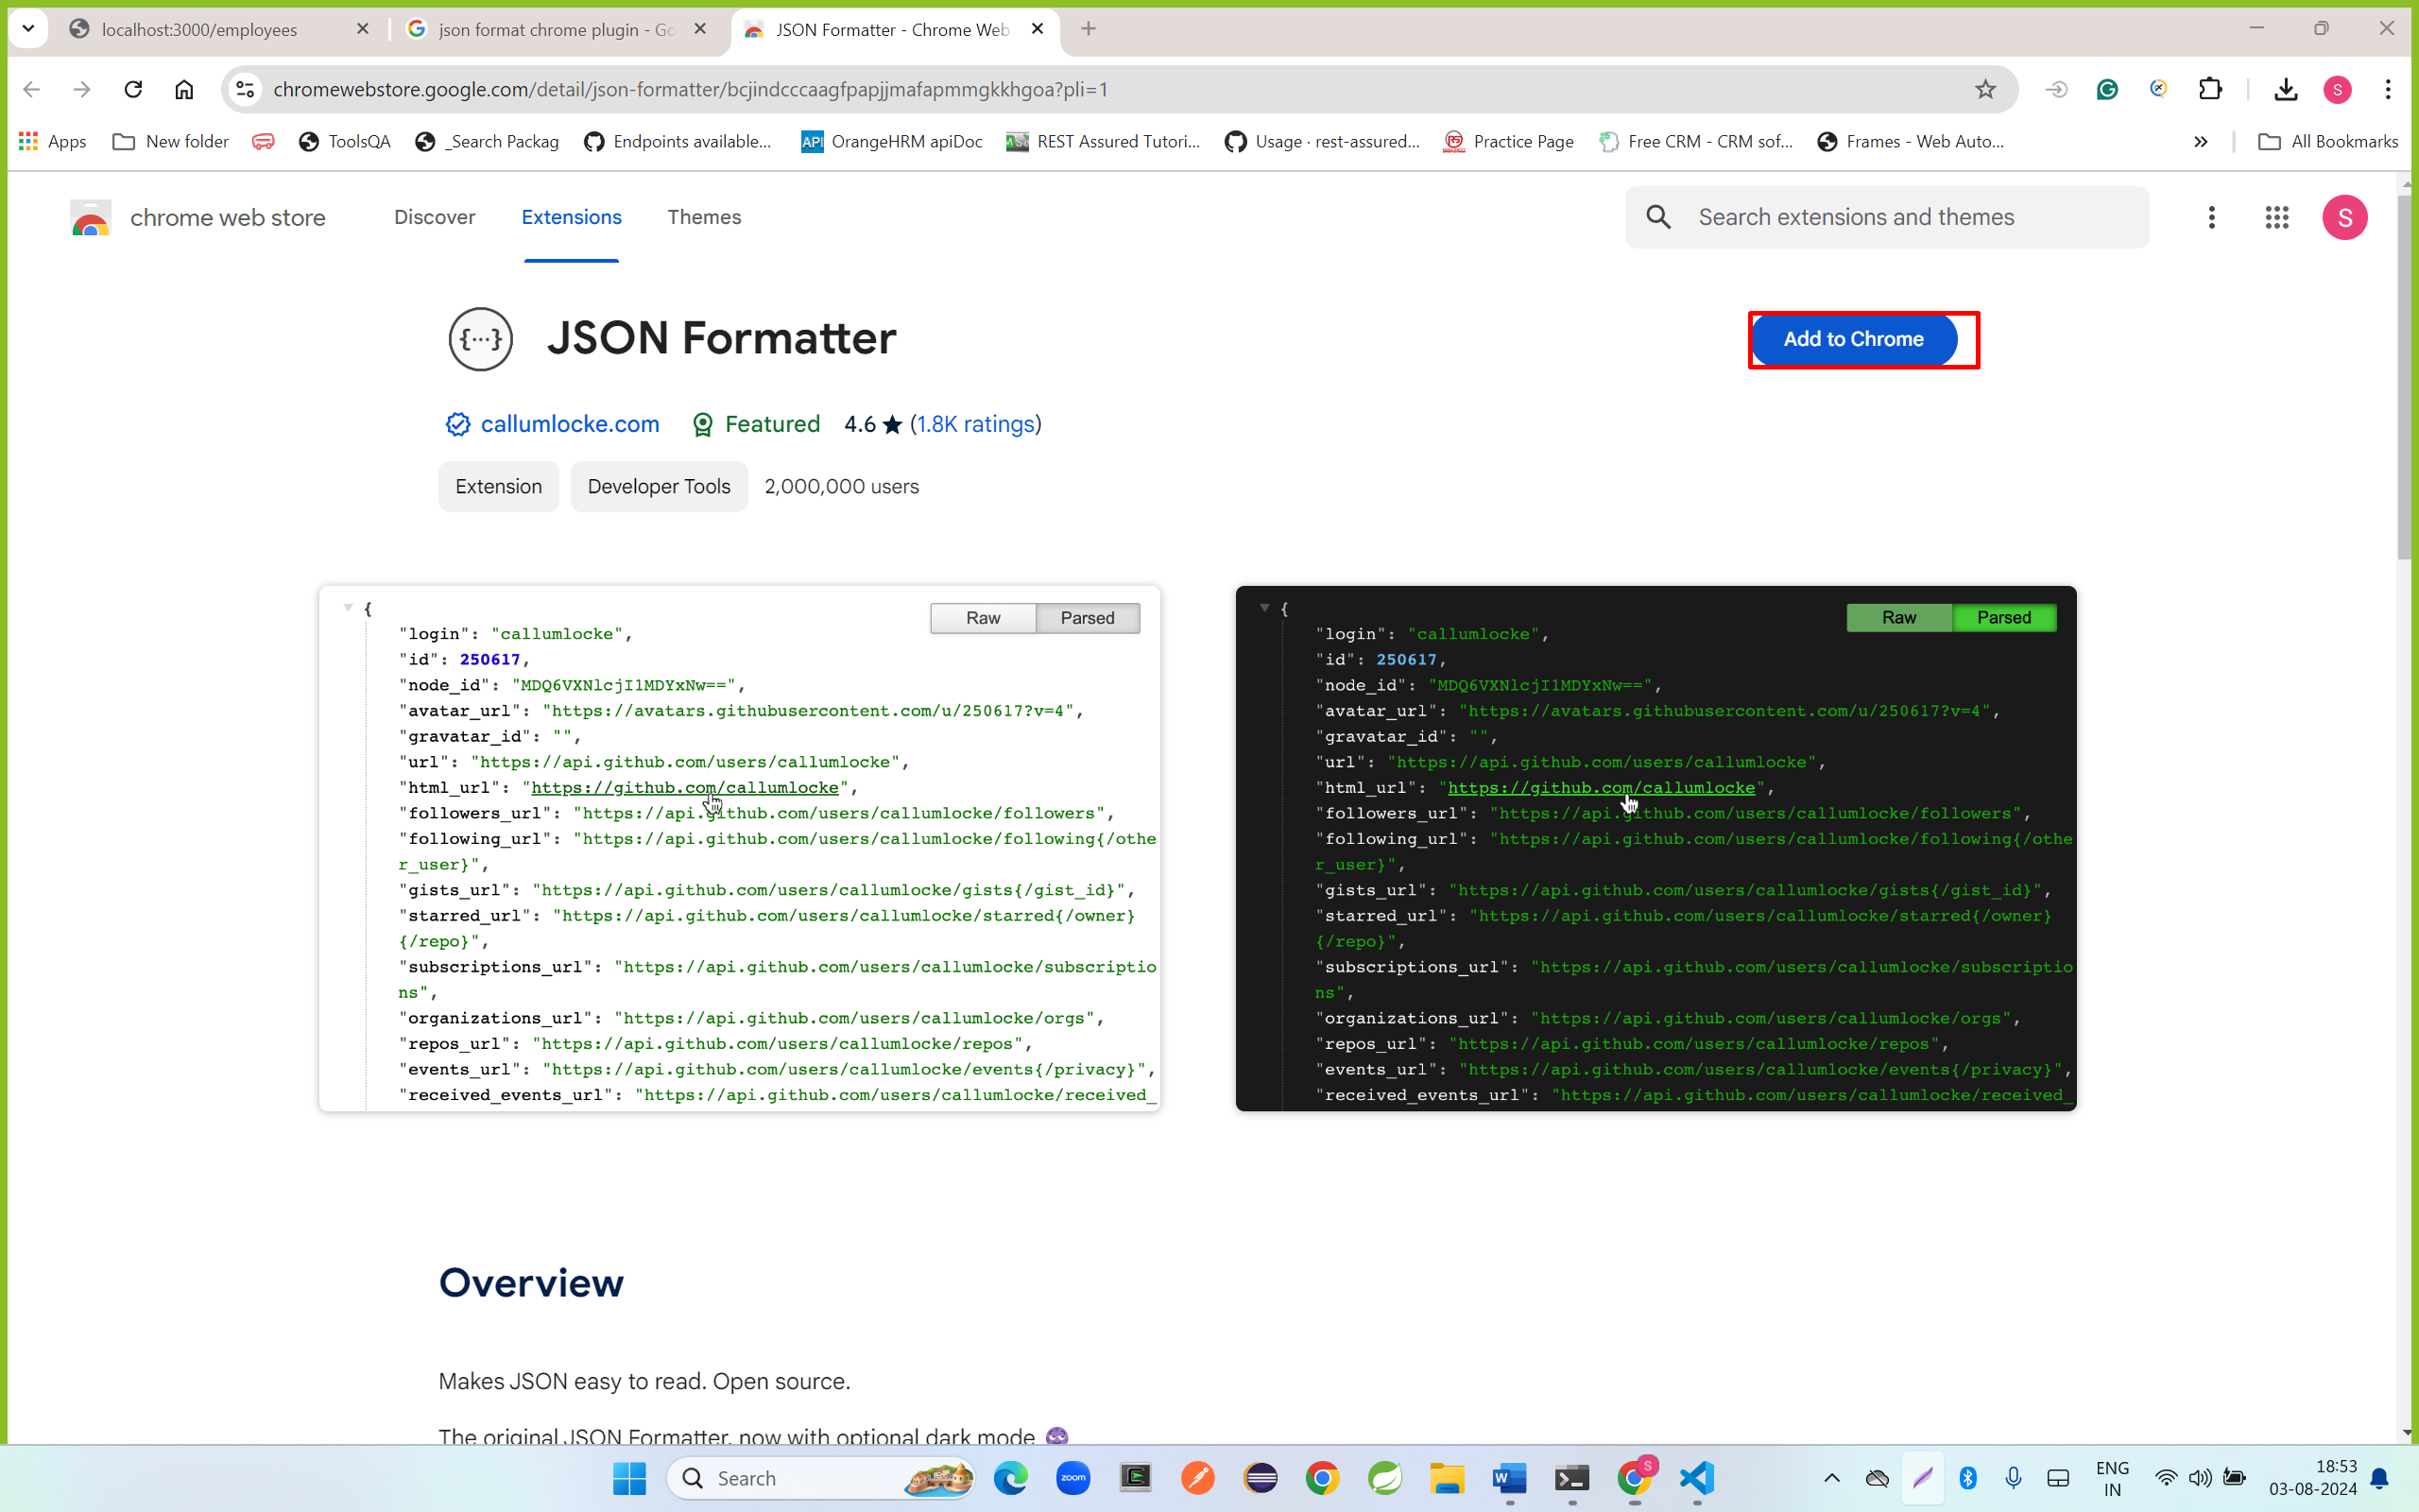

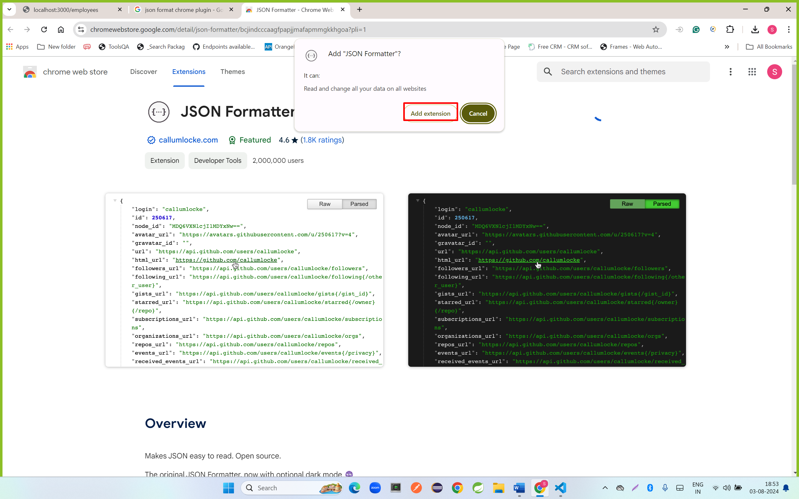

Open a url <http://localhost:3000/employees>

